# https://upload.wikimedia.org/wikipedia/en/f/f1/Capital_University%2C_Jharkhand_logo.png

# CAPITAL UNIVERSITY - KODERMA

ELECTRO-MECHANICAL ENERGY CONVERSION DEVICE ASSIGNMENT

Name : Arshad Nazir

Electrical and Electronics Engineering

1. Define EMF and MMF.

Electromotive force is the work done on a charge to move it from one point to another in an electric field

Magneto-motive force is the force required to set magnetic field to a magnetic circuit

1. Name the main magnetic quantities with their symbols having the following units: Webers, Telsa , AT/Wb , H/m.

Weber is the unit of Magnetic flux. The symbol is Φ.

Tesla is the unit of Magnetic flux density. The symbol is B.

Ampere turns per weber (AT/Wb) is the unit of Reluctance. The symbol is R. Henry per meter is the unit of Magnetic Permeability. The symbol is μ.

1. Define magnetic field intensity, flux and flux density.

Magnetic field intensity (H) at any point in the magnetic field is defined as the force experienced by a unit charge at that point.

Magnetic flux (Φ) is the measure of total magnetic field passes through a given area.

Flux density (B) is the measure of the number of magnetic lines of force per unit of cross-sectional area

1. Define inductance.

Inductance is the property of a conductor to generate an electro motive force when there is a change in flow of current.

1. Define magnetic reluctance.

Magnetic reluctance is the opposition offered by the magnetic circuit to the production of magnetic flux (Φ).

1. Define reluctance and permeance.

Magnetic reluctance is the opposition offered by the magnetic circuit to the production of magnetic flux (Φ).

Permeance is defined as a measure of ease to admit magnetic flux (Φ) through a material or magnetic circuit.

1. How will you minimize hysteresis and eddy current losses?

Hysteresis loss can be reduced by increasing the number of laminations which are supplied through fever gaps among plates.

In order to reduce Eddy current loss, resistance of the core should be increased. In other words, low reluctance path should be maintained.

1. Define Torque.

Torque is a force that produces or tends to produce a rotational motion.

1. What is transformer and its basic principle?

A transformer is a static device which transfers AC electrical from one circuit to another at constant frequency, but different levels of voltage. It works on the principle of Faraday’s Electromagnetic induction.

1. Define stacking factor.

The stacking factor is a measure used in electrical transformer design and some other electrical machines. It is the ratio of effective cross-sectional area of the transformer to the physical cross-sectional area of the transformer.

## PART 1A

1. Explain the similarities and dissimilarities between electric and magnetic circuits.

|  |  |
| --- | --- |
| Electric circuit | Magnetic circuit |
| 1. In an electrical circuit, electric current flows through the closed path. | 1. In the magnetic circuit, magnetic flux flows through the closed path. |
| 2. In an electrical circuit, electric current flows from positive to negative polarities. | 2. In the magnetic circuit, magnetic flux flows from N-pole to S-pole. |
| 3. In an electrical circuit, an electro- motive force (EMF) is used to produce the electric current. | 3. In the magnetic circuit, magneto- motive force (MMF) is used to produce the magnetic flux. |
| 4. In an electrical circuit,  the resistance (R) opposes the flow of electric current. | 4. In the magnetic circuit, the reluctance (S) opposes the flow of magnetic flux. |
| 5. Conductance (G) is the reciprocal of the resistance. | 5. Permeance (P) is the reciprocal of reluctance. |
| 6. Current density (δ) is the rate of the electric currents flowing per unit cross-sectional area of a material. | 6. Flux density (B) is the rate of the magnetic fluxes flowing per unit cross-sectional area of a material. |
| 7. Electric field strength (intensity) E, is the electro-motive force per unit electric charge. | 7. Magnetic field strength (intensity) H, is the magneto-motive force per unit length. |
| 8. The electrical circuit can be a closed circuit or an open circuit. | 8. The magnetic circuit is always a closed circuit. |

1. a) Explain the AC operation of a magnetic circuits.

b) Explain clearly the statically and dynamically induced EMF.

1. For establishing a magnetic field, energy must be spent, though to energy is required to maintain it. Take the example of the exciting coils of an electromagnet. The energy supplied to it is spent in two ways, (i) Part of it goes to meet I2R loss and is lost once for all (ii) part of it goes to create flux and is stored in the magnetic field as potential energy, and is similar to the potential energy of a raised weight, when a mass M is raised through a height of H, the potential energy stored in it is mgh. Work is done in raising this mass, but once raised to a certain height. No further expenditure of energy is required to maintain it at that position. This mechanical potential energy can be recovered so can be electric energy stored in a magnetic field. When current through an inductive coil is gradually changed from Zero to a maximum, value then every change of it is

opposed by the self-induced emf. Produced due to this change. Energy is needed to overcome this opposition. This energy is stored in the magnetic field of the coil and is, later on, recovered when those field collapse.

In many applications and machines such as transformer and a.c machines, the magnetic circuits are excited by a.c supply. In such an operation, Inductance plays vital role even in steady state operation though in d.c it acts as a short circuit. In such a case the flux is determined by the a.c voltage applied and the frequency, thus the exciting current has to adjust itself according to the flux so that every time B-H relationship is satisfied.

1. When the conductor is stationary and the magnetic field is changing, the induced EMF in such a way is known as staticallyinducedEMF(as in a transformer). It is so called because the EMF is induced in a conductor which is stationary.

When the conductor is moved in a stationary magnetic field so that the magnetic flux linking with it changes in magnitude, as the conductor is subjected to a changing magnetic, therefore an EMF will be induced in it. The EMF induced in this way is known as dynamicallyinducedEMF(as in a DC or AC generator). It is so called because EMF is induced in a conductor which is moving (dynamic).

1. Define the following: (a) magnetic flux and flux density (b) reluctance (c) permeance

(d) mmf (e) magnetic field intensity (f) permeability of free space.

* 1. Magnetic flux is defined as the number of magnetic field lines passing through a given closed surface. It provides the measurement of the total magnetic field that passes through a given surface area.

Magnetic Flux Density Flux density is the measure of the number of magnetic lines of force per unit of cross-sectional area.

* 1. Magnetic reluctance is the opposition offered by the magnetic circuit to the production of magnetic flux.
  2. Magnetic permeance is the ease to admit magnetic flux in a magnetic circuit.
  3. Magneto-motive force (MMF) is the force required to set magnetic field to the magnetic circuit.
  4. Magnetic field intensity (H) at a point in a magnetic field is the force experienced by a unit charge at that point.
  5. The permeability of free space, is a measure of the amount of resistance encountered when forming a magnetic field in a classical vacuum.

1. Define the following terms.

(i) MMF and Lenz’s Law (ii) Faraday’s Law of Electro Magnetic Induction (iii) Parallel and series magnetic circuits (iv) Torque and Permeability.

* 1. Magneto-motive force (MMF) is the force required to set magnetic field to the magnetic circuit.

Lenz’s law states that induced electromotive force with different polarities induces a current whose magnetic field opposes the change in magnetic flux through the loop in order to ensure that original flux is maintained through the loop when current flows in it.

* 1. Faraday’s law of electromagnetic induction states that, whenever a conductor is placed in varying magnetic field an electro-motive force is induced.
  2. A magnetic circuit that consists of more than one path for the flux is called are called parallel magnetic circuits.

When the same magnetic flux ψ flows through each part of the magnetic circuit, then the circuit is called as series magnetic circuit.

* 1. Torque is a force that produces or tends to produce a rotational motion. Permeability is the measure of ease to admit lines of magnetic flux.

## PART 2

1. Differentiate between a core and shell type transformer.

In a core type transformer the winding encircles the core, whereas in shell type transformer, the core encircles the winding.

1. What is the basic purpose of tertiary winding?

The basic use of the tertiary winding is to reduces the unbalancing in the primary due to unbalancing in three phase load.

1. Define regulation of a transformer.

The voltage regulation of a transformer is defined as the arithmetic difference between secondary voltages at no-load and rated full load at a given power factor for the primary voltage at no-load and full load.

1. State the advantages and applications of auto transformer.

Advantages:

* + Cheaper
  + More efficient, because losses stay the same while the rating goes up compared to a conventional transformer.
  + Lower exciting current.
  + Better voltage regulation.

Applications:

* + They are generally used to connect transmission lines of slightly different voltages (e.g., 115 kV and 138 kV or 138 kV and 161 kV).
  + They are employed to compensate for voltage drops on long feeder circuits where it is important that each load device receives the same voltage.
  + They offer variable voltage control in the laboratory setup: as we move the sliding contact, virtually all of the coil can become the series coil. Therefore, the entire coil must be sized for maximum current.
  + They are used to adjust the transformer output voltage in order to keep the system voltage constant with varying load.

1. What happens if DC supply is applied to the transformer?

When dc supply is given to a transformer its primary winding will burn away. A constant dc voltage on primary winding of transformer will have zero induced EMF.

1. Give the principle of transformers.

The basic working principle of transformer is Faraday’s law of Electro-magnetic induction, i.e. whenever a conductor is placed in a varying magnetic field an EMF is induced in the conductor. In a transformer, the changing magnetic field due to the current flowing in primary of the transformer induces an EMF in the secondary coil of the transformer.

1. What are the condition for parallel operation of a transformer?

* The parallel connected transformers should have same polarities.
* The parallel connected transformers must have identical primary and secondary voltage ratings.
* The winding reactance to the resistance ratios in the parallel connected transformers should be the same.
* The phase sequence of all the parallel connected transformers must be the same.
* The phase shift between the primary and secondary voltages must be the same for all the parallel connected transformers.
* All the parallel connected transformers should be in the same vector group.

1. Why is transformer rated in KVA?

Transformers are rated in KVA because the losses in transformers are independent of power factor. KVA is the unit of apparent power. It is the combination of real power and reactive power.

1. What is an auto transformer?

Transformer in which there will only be one winding which is common to both

primary and secondary is called Autotransformer. The term Auto here refers to that the voltage input variations will be automatically can be improved or can be reduced utilizing the single winding.

1. What is an ideal transformer?

A transformer which has no loss is called an ideal transformer. An imaginary transformer which has no core, no ohmic resistance and no leakage flux.

## PART 2A

1. Explain the principle of operation of a transformer. Draw the vector diagram to represent a load at UPF, lagging and leading power factor.

The basic working principle of transformer is Faraday’s law of Electro-magnetic induction, i.e. whenever a conductor is placed in a varying magnetic field an EMF is induced in the conductor. In a transformer, the changing magnetic field due to the current flowing in primary of the transformer induces an EMF in the secondary coil of the transformer. The number of turns in the primary and secondary coils determines whether it is a step-up or step-down transformer. If primary winding has less number of coils than secondary, it is a step-up transformer or else it is step-down.

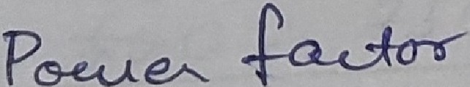

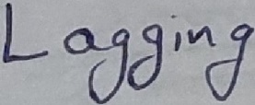

"o(fW

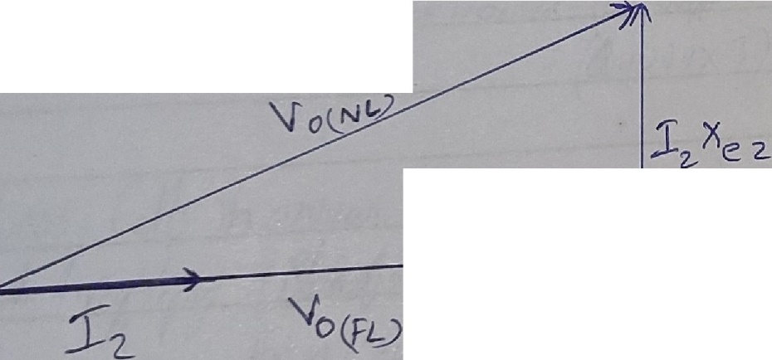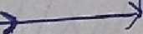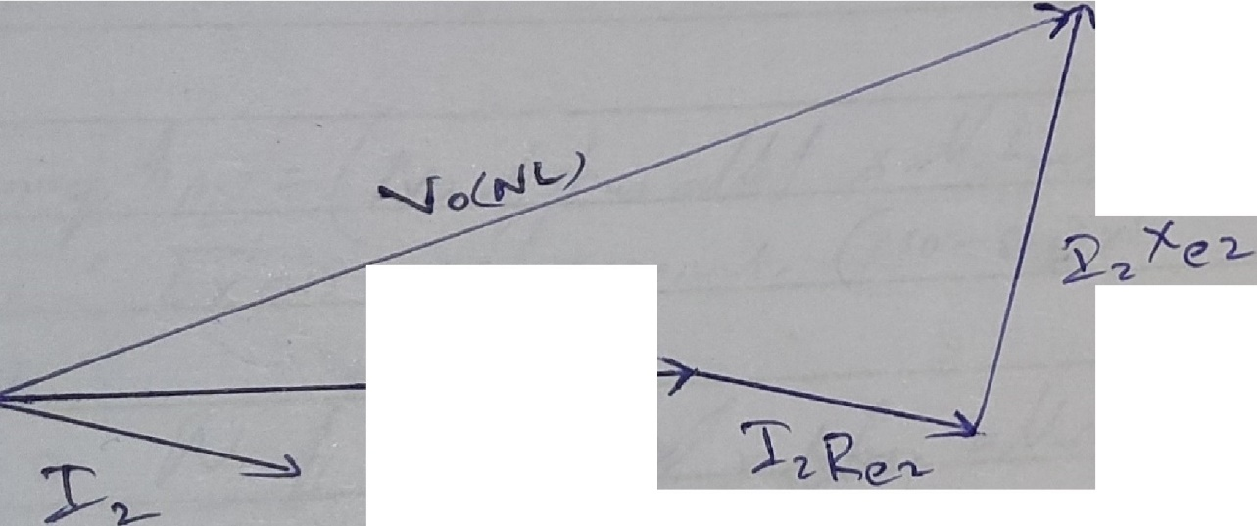

; "2--*1?****er-***

UPF

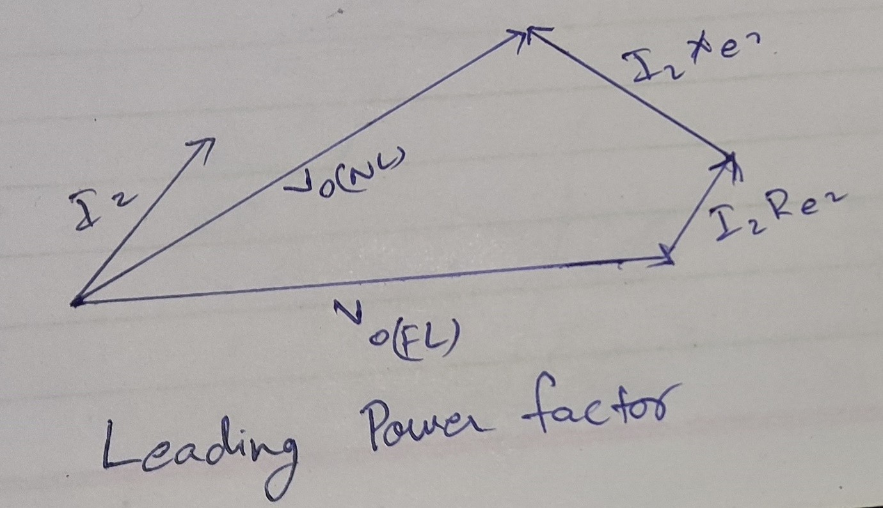

1. Obtain the equivalent circuit of a single phase transformer referred to primary and secondary.

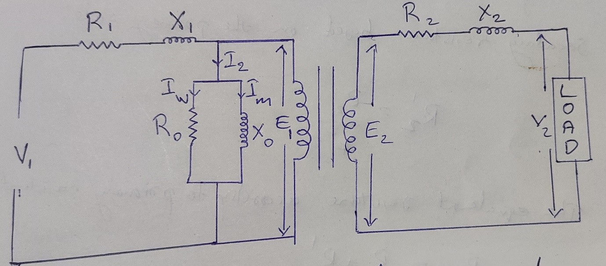

Fig. 1: Equivalent circuit of a transformer

Equivalent circuit is defined on the basis of transformer ratio:

K=E2/E1

Second current,

I2 = I1’/K = (I1-I0)/K

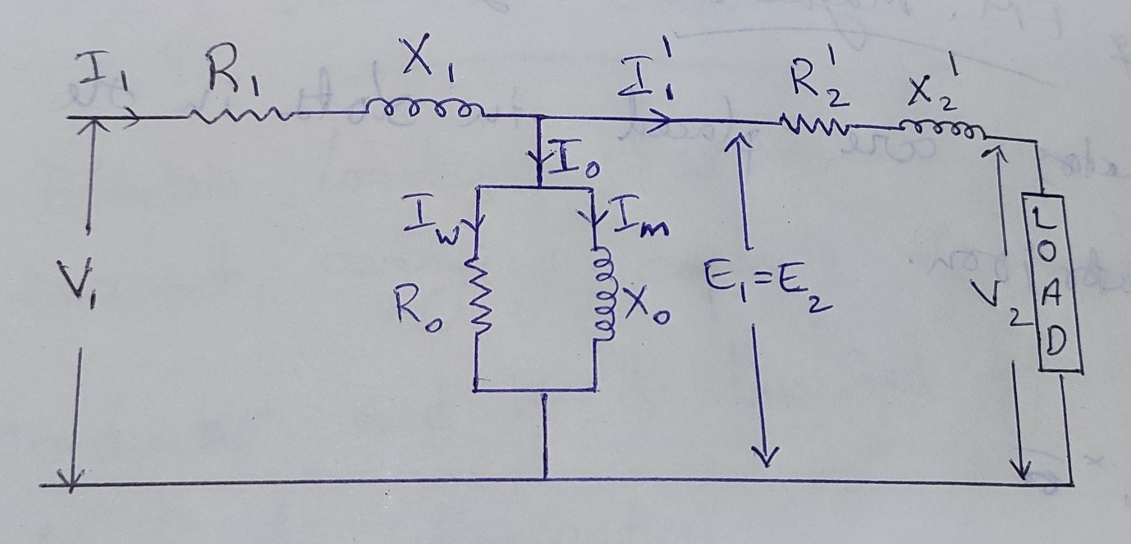

Fig. 2: Equivalent circuit referred to the primary side of transformer

Secondary resistance based on primary side:

R2’ = R2/K2

The equivalent resistance according to primary consideration:

Rep = R1+R2’

Secondary reactance according to primary side:

X2’ = X2/K2

The equivalent reactance according to primary:

Xep = X1 + X2’

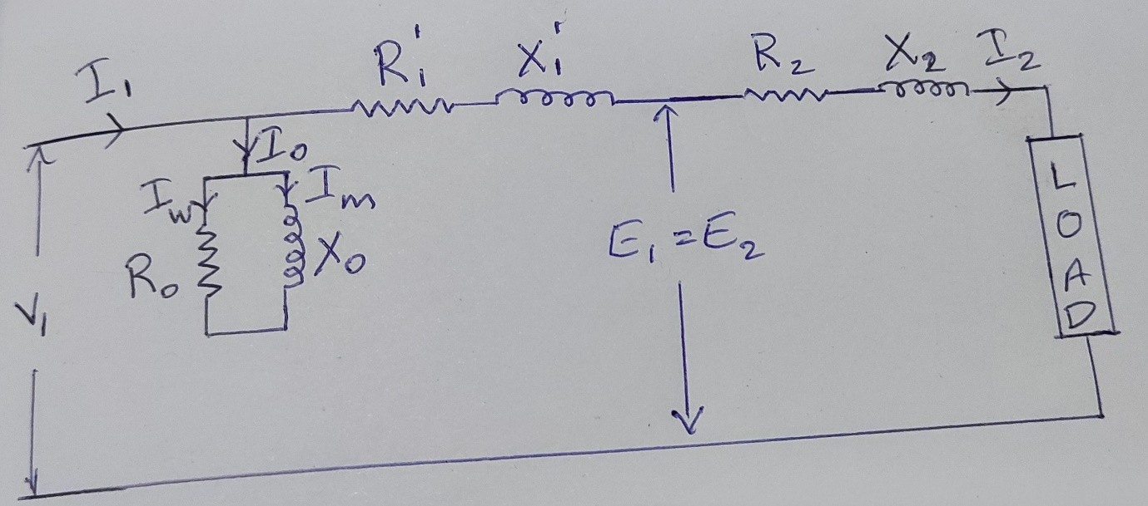

Fig. 3: Equivalent circuit referred to the secondary side of transformer

Basic Resistance based on the secondary side:

R1’ = K2 * R1

Equivalent resistance according to secondary terms:

Res = R2 + R1’

Basic Reactance based on the secondary side:

X1’ = K2 * X1

Equivalent reactance according to secondary terms:

Xes = X2 + X1’

1. Explain the construction and working principle of a transformer.
   * A transformer works on the principle of **electromagnetic induction** between two coupled circuits or coils.

#### Working

* + When an alternating voltage V1 is applied to the primary, an alternating flux ø

is set up in the core.

* + This alternating flux links both the windings and induces e.m.fs E1 and E2 in them according to Faraday’s laws of electromagnetic induction.
  + The e.m.f E1 is termed as primary e.m.f and e.m.f E2 is termed as secondary e.m.f, magnitudes of E2 and E1 depend upon the number of turns on the secondary and primary respectively.
  + If N2 > N1, then E2 > E1 (or V2 > V1) and we get a step-up transformer.
  + If N2 < N1, then E2 < E1 (or V2 < V1) and we get a step-down transformer.

#### Construction

* A transformer in its simplest form will consist of a rectangular laminated magnetic structure on which two coils of different number of turns are wound.
* The winding to which a.c voltage is impressed is called the primary of the transformer and the winding across which the load is connected is called the secondary of the transformer.
* The alternating voltage V1 whose magnitude is to be changed is applied to the primary.
* Depending upon the number of turns of the primary (N1) and secondary (N2), an alternating e.m.f E2 is induced in the secondary.
* This induced e.m.f E2 in the secondary causes a secondary current I2.
* Consequently, terminal voltage V2 will appear across the load.
* If V2 > V1, it is called a step up-transformer.
* If V2 < V1, it is called a step-down transformer.

1. With neat sketch explain the working of transformer under no-load and lagging power factor load.

#### No load

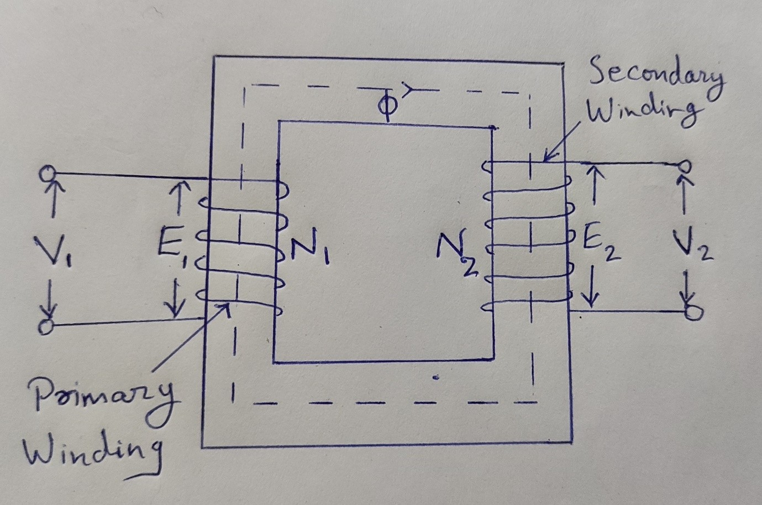

Transformer connected under no load condition

When the primary of a transformer is connected to the source of ac supply and the secondary is open, the transformer is said to be at no-load i.e. Transformer on no load (there is no load on secondary).

Consider, an ideal transformer whose secondary side is open and the primary winding is connected to a sinusoidal alternating voltage V1. The alternating voltage applied to the primary winding will cause flow of alternating current in the primary winding. Since the primary coil is purely inductive and there is no output (secondary being open) the primary draws the magnetising current Im only.

The function of this current is merely to magnetize the core. If the transformer is truly ideal, the magnitude of Im should be zero by virtue of assumption (iv) made for Ideal transformer. Since, the reluctance of the magnetic circuit is never Zero, Im has definite magnitude. The magnetising current, Im is small in magnitude and lags behind supply voltage V1 by 90″. This magnetising current Im, produces an alternating flux  which is, at all times, proportional to the current (assuming permeability of

the magnetic circuit to be constant) and, hence, in phase with it.

**Lagging power factor load**

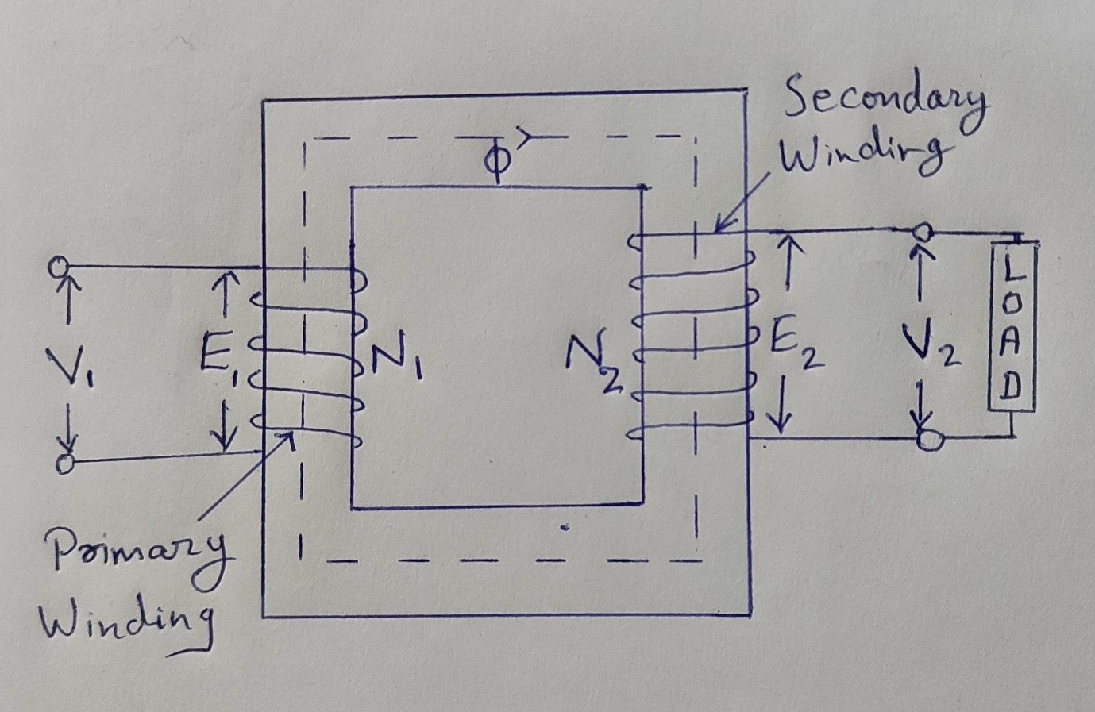

* When the load is connected to the secondary of the transformer, I2 current flows through their secondary winding. The secondary current induces the magnetomotive force N2I2 on the secondary winding of the transformer. This force set up the flux φ2 in the transformer core. The flux φ2 opposes the flux φ, according to **Lenz’s law**.
* As the flux φ2 opposes the flux φ, the resultant flux of the transformer decreases and this flux reduces the induced EMF E1. Thus, the strength of the V1 is more than E1 and an additional primary current I’1 drawn from the main supply.

The additional current is used for restoring the original value of the flux in the core of the transformer so that V1 = E1. The primary current I’1 is in phase opposition with the secondary current I2. Thus, it is called the **primary counter**

#### -balancing current.

* The phase difference between V1 and I1 gives the power factor angle ϕ1 of the primary side of the transformer.
* The power factor of the secondary side depends upon the type of load connected to the transformer.
* If the load is inductive as shown in the above phasor diagram, the power factor will be lagging, and if the load is capacitive, the power factor will be leading. The total primary current I1 is the vector sum of the currents I0 and I1’. i.e,

I1 = I0 + I1’

## PART 3

1. Draw the general block diagram of electromechanical energy conversion device.

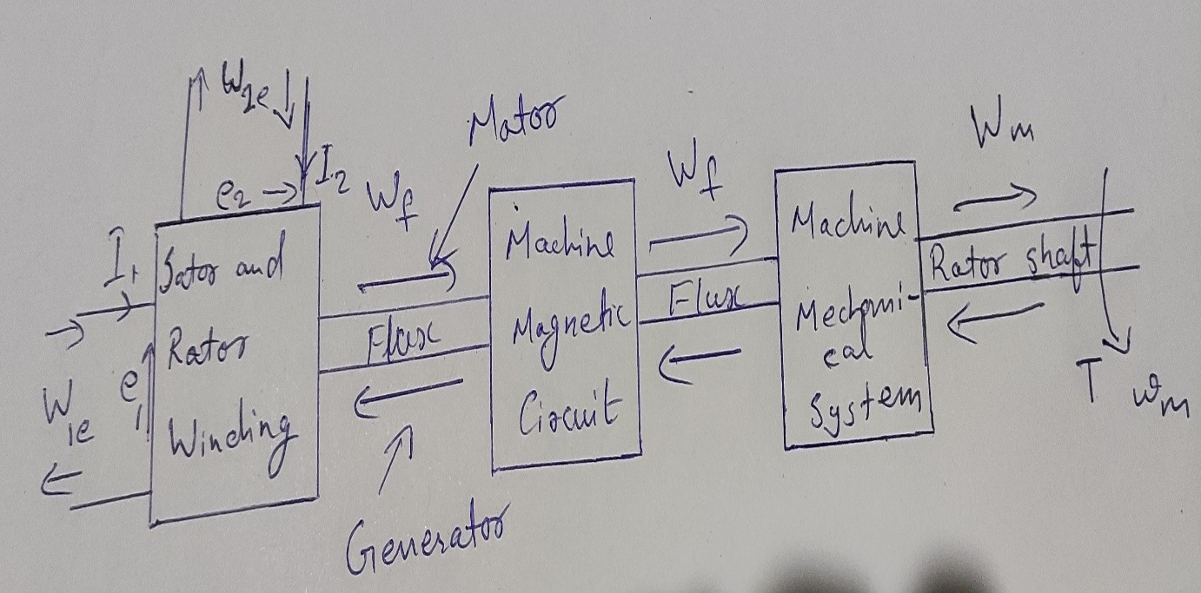

1. Write an expression for stored energy in the magnetic field.

Energy stored in magnetic field:

UB = B2/(2 * μ0)

1. Define winding factor.

The **winding factor** is the method of improving the RMS generated voltage in a three- phase AC machine so that the torque and the output voltage do not consist of any harmonics which reduces the efficiency of the machine**. Winding Factor** is defined as the product of the Distribution factor (Kd) and the coil span factor (Kc).

1. What do you mean by coenergy?

In physics and engineering, **Coenergy** (or **co-energy**) is a non-physical quantity, measured in energy units, used in theoretical analysis of energy in physical systems. The concept of co-energy can be applied to many conservative systems (inertial mechanical, electromagnetic, etc.), which can be described by a linear relationship between the input and stored energy.

1. The main requirement of an excitation system is:
   * Reliability under all conditions of service
   * A simplicity of control
   * Ease of maintenance
   * Stability and fast transient response
2. What is meant by reactance voltage?

The reactance voltage is the induced voltage in the winding due to the reversal of the current. So, reactance voltage is the product of self- inductance of the winding and rate of change of current.

1. Why fractional pitched winding is preferred over full pitched winding?
   * Waveform of the EMF can be approximately made to a sine wave and distorting harmonics can be reduced or totally eliminated.
   * Conductor material, copper, is saved in the back and front end connections due to less coil-span.
   * Fractional slot winding with fractional number of slots/phase can be used which in turn reduces the tooth ripples.
   * Mechanical strength of the coil is increased.
2. Enumerate the advantages of using short pitched winding in a synchronous machine.
   * Short Pitching reduces the amount of copper needed for End Connection when compared with Full Pitched Coil as can be observed from the figure above.
   * They improve the waveform of generated EMF i.e. generated EMF can be made to approximate to a sine wave more easily and the distorting harmonics can be reduced or totally eliminated.
   * Due to the elimination of high frequency harmonics, eddy current and hysteresis losses are reduced, thereby increasing the efficiency.
3. Why synchronous machine does not produce torque at any other speed?

This is a self-regulatory behaviour; it prevents a machine from going into a runaway state.

1. State the principle of electromechanical energy conversion.

The principle of conservation of energy states that “the energy can neither be create not destroyed. It can only be converted from one form to another”.

## **PART 3A**

1. Describe the flow of energy in electromechanical devices.

Electromechanical energy conversion is a reversible process. If the armature is allowed to move on positive x direction under the influence of Field, electrical energy

is converted to mechanical form via the coupling field. If instead the armature is moved in the negative x direction under the influence of external force, mechanical energy is converted to electrical form via the coupling field. This conversion process is not restricted to translatory devices as illustrated but is equally applicable to rotatory devices. Electrical and mechanical losses cause irreversible flow of energy out of a practical conversion device. The flow of energy in electromechanical conversion in either direction along with irrecoverable energy losses is shown in figure.

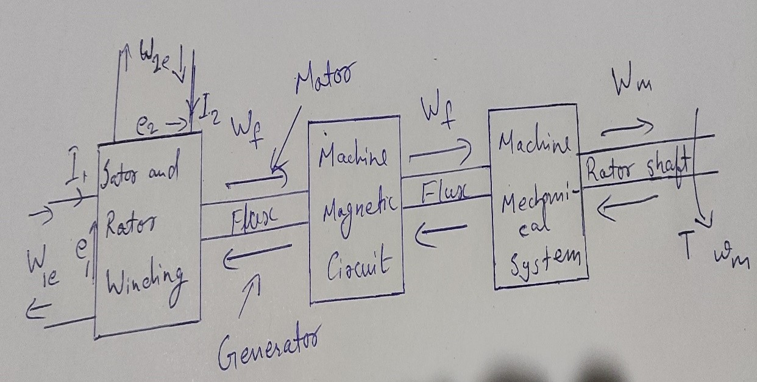

1. Discuss about the ‘field energy’ and ‘coenergy’ in magnetic system.

In a magnetically linear system, the field energy is given by,

# Wf = ∫ ψ idψ

*0*

∵i=ψ/L or ψ=Li

∴Wf = ∫0ψ (ψ/L)*dψ = ψ2/2L

# ⟹Wf=(Li)2 /2L=1/2*Li2

⟹Wf = ψ2 /2L =1/2*Li2 ...(1)

The expression in the eq.(1) gives the field energy stored in a magnetically linear system.

The coenergyis a non-physical quantity measured in the units of energy, which is used to derive expressions for force or torque developed in an electromagnetic system. The concept of coenergy cannot be applied to non- linear systems.

For a magnetically linear system, the coenergy is given by,

# W’f= ∫i0ψdi = ∫i0Lidi =1/2*Li2...(2)

The eq. (2) shows that the coenergy in the magnetically linear system is equal

to the area between the ψ-i curve for the system and the current (i) axis.

It is clear from the eq. (1) and (2) that for a magnetically linear system, the field energy and coenergy are equal.

# Wf= Wf’=ψ2/2L=1/2*Li2...(1)

1. Explain the concept of rotating magnetic field.

A rotating magnetic field is the resultant magnetic field produced by a system of coils symmetrically placed and supplied with polyphase currents. A rotating

magnetic field can be produced by a poly-phase (two or more phases) current or by a single phase current provided that, in the latter case, two field windings are supplied and are so designed that the two resulting magnetic fields generated thereby are out of phase.

Derive the torque equation in round rotor machines.

If Fs, Fr and λ be the stator field strength, rotor field strength and angle between Fs & Fr, then the torque is given as

Te = FsFrSinλ

The above torque equation is a general equation applicable for all rotating electrical machine. In this post we will derive a general torque equation for synchronous machine. For this purpose, let us consider a uniform air gap two pole machine.

Current in the stator winding produces stator mmf which is assumed to be sinusoidally distributed in the air gap periphery. The peak value of this stator mmf Fs is directed along the stator winding axis as shown in figure. In the above figure, Fs is taken horizontal with Fs directed from left to right. Similarly, rotor current produces rotor mmf which is also assumed sinusiodally distributed in the air gap. The peak value of rotor mmf Fr is along the rotor winding axis as shown in figure. It should be noted that Fs and Fr is the peak value of resultant mmf due to all stator and rotor winding.

These stator and rotor mmf in turn causes appearance of stator and rotor poles. Stator mmf Fs causes appearance of North pole in the left side whereas South pole at the right side of stator. Similarly, North and South pole are produced due to rotor mmf as shown in figure. These stator and rotor magnetic poles interact with each other and tend to align their magnetic axis. This results in development of electromagnetic torque.

For deriving general torque equation for synchronous motor / generator, following assumptions are made:

* The stator and rotor iron have infinite permeability. This effectively means that saturation is neglected.
* All the magnetic flux crosses the air gap perpendicularly. This means that flux leakage is assume to be absent.
* The air gap length is very small when compared to the axial length of synchronous machine. This means that the value of flux density at stator surface, rotor surface and at any point in the air gap is same.
* Only fundamental sine component of stator and rotor mmf wave is considered.

Based on the above assumptions, the torque equation for any rotating electrical machine is given as

#### Te = -(π/8)P2ØFsSinδs Nm

**= -(π/8)P2ØFrSinδr Nm** P = Number of poles

Ø = Resultant air gap flux per pole Fr = Rotor mmf

Fs = Stator mmf

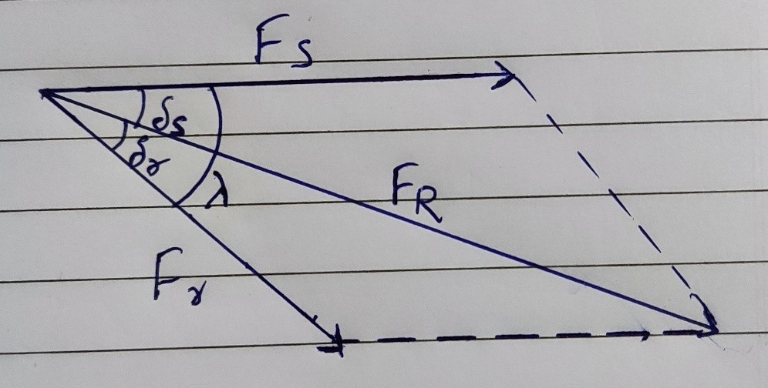

In the above phasor, FR is the resultant of stator mmf Fs and rotor mmf Fr. The angle between Fr & FR i.e. δr is called the **loadangle**. Similarly, the angle between the resultant air gap flux FR and Stator mmf Fs i.e. δs is called load angle. The angle λ between the stator and rotor mmf is called the torque angle.

The negative sign in the torque equation of synchronous machine implies that electromagnetic torque acts in such a direction to minimize the torque angle λ. It must be noted here that, the above torque equation is valid not only for synchronous motor or generator rather it is valid for all rotating electrical machine.

## PART 4

1. What is the difference between Lap winding and Wave Winding of a DC Machine armature?

|  |  |
| --- | --- |
| LAP WINDING | WAVE WINDING |
| 1. The coil is lap back to the succeeding coil. | 1. The coil of the winding form the wave shape. |
| 2. The end of the armature coil is connected to an adjacent segment on the commutators. | 2. The end of the armature coil is connected to commutator segments some distance apart. |
| 3. The numbers of parallel path are equal to the total of number poles. | 3. The number of parallel paths is equal to two. |
| 4. Less | 4. More |
| 5. High | 5. Low |

1. List the factors involved in the voltage build-up of a shunt generator.
   * There must be same residual magnetism in poles.
   * For the given direction of rotation the shunt field coils should be correctly connected to the armature i.e. they should be so connected that the induced current reinforce the emf produced initially due to resident magnetism.
   * If excited on open circuit its shunt field resistance should be less than the critical resistance.
   * If excited on load, then its shunt field resistance should be more than certain minimum value of resistance which is given by internal character.
2. What are the requirements of the excitation systems?

Excitation systems supply and regulate the amount of D.C current required by generator field windings and include all power regulating control and protective elements. The excitation system should be specified to

meet the power requirements and required response characteristics to meet the power system to which generator will be connected.

1. Why fractional pitched winding is preferred over full pitched winding?
   * Waveform of the EMF can be approximately made to a sine wave and distorting harmonics can be reduced or totally eliminated.
   * Conductor material, copper, is saved in the back and front end connections due to less coil-span.
   * Fractional slot winding with fractional number of slots/phase can be used which in turn reduces the tooth ripples.
   * Mechanical strength of the coil is increased.
2. Define winding factor.

The **winding factor** is the method of improving the RMS generated voltage in a three- phase AC machine so that the torque and the output voltage do not consist of any harmonics which reduces the efficiency of the machine**. Winding Factor** is defined as the product of the Distribution factor (Kd) and the coil span factor (Kc).

1. What is armature reaction in DC generators? What are its effects?

The current flowing through the armature conductors creates a magnetic field, which is called as armature flux. This armature flux distorts and weakens the magnetic flux produced by the main poles. This effect of armature flux on the main flux is known as armature reaction.

The armature reaction in a DC generator causes the following adverse effects:

* + As the total field flux produced by each pole is slightly reduced, which reduces the generated EMF.
  + Due to the shifting of the resultant flux axis, the MNA is also shifted in the direction of rotation of the generator.
  + Due to the armature reaction, a flux is established in the commutating zone or neutral zone. This flux in the neutral zone induces conductor voltage that causes the commutation problems.

1. Write the EMF equation of DC generator explaining all terms.

EMF equation of a DC generator is:

Eg=PφNZ/60A

P = Number of poles in the machine N = Speed of armature in RPM

Z = Total number of armature conductors A = Number of parallel paths

1. Mention the uses of DC generators.
   * The separately excited type DC generators are used for power and lighting purposes.
   * The series DC generator is used in arc lamps for lighting, stable current generator and booster.
   * DC generators are used to reimburse the voltage drop within Feeders.
   * DC generators are used to provide a power supply for hostels, lodges, offices, etc.
2. Give few applications of Ward-Leonard systems.

Some applications of Ward-Leonard system:

* + Mine hoists
  + Elevators
  + Steel rolling mills
  + Paper machines
  + Cranes

1. Draw the External Characteristics of a |Shunt generator.

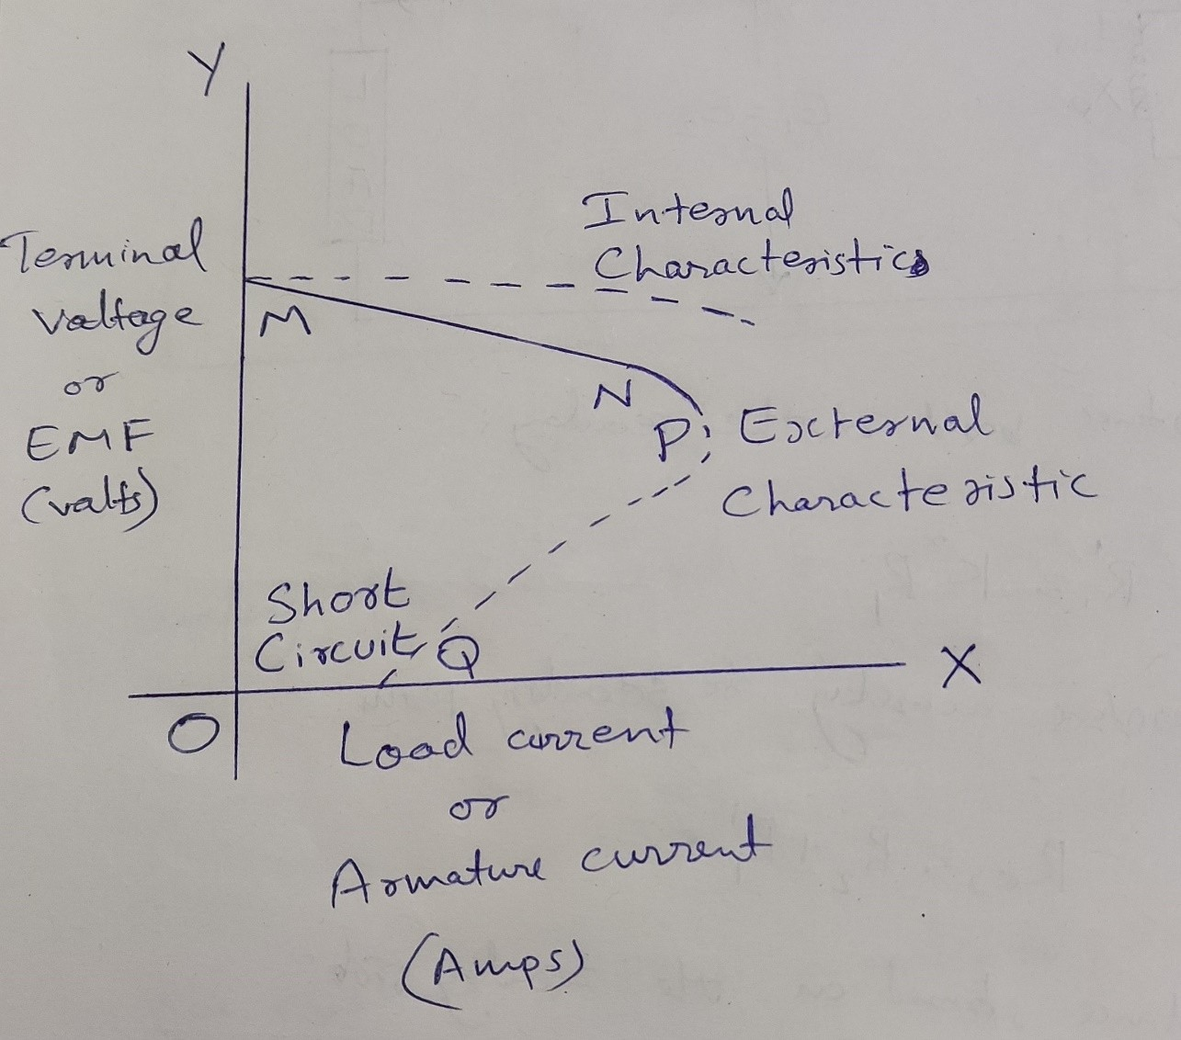

1. What are the Characteristics of DC generators?

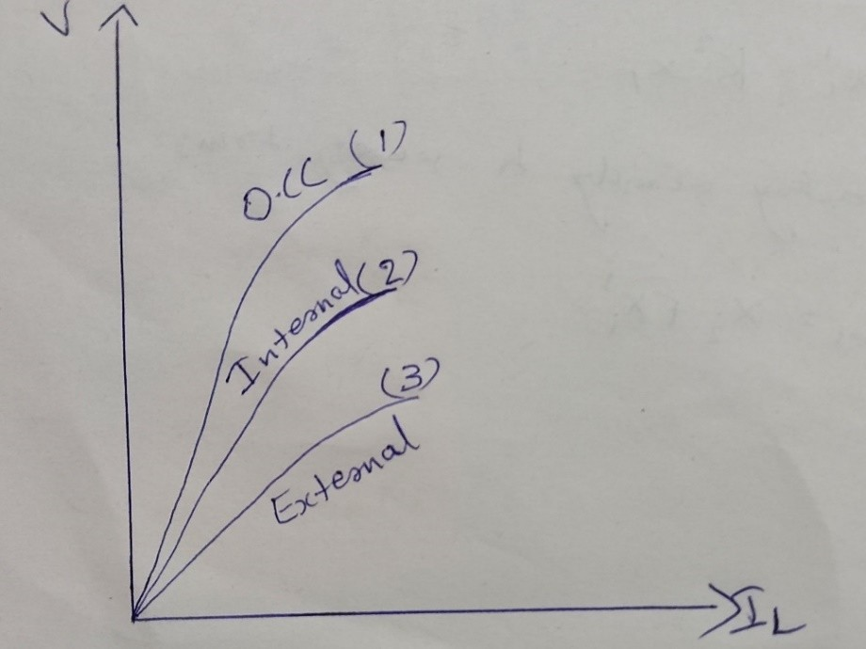

DC Series Generator

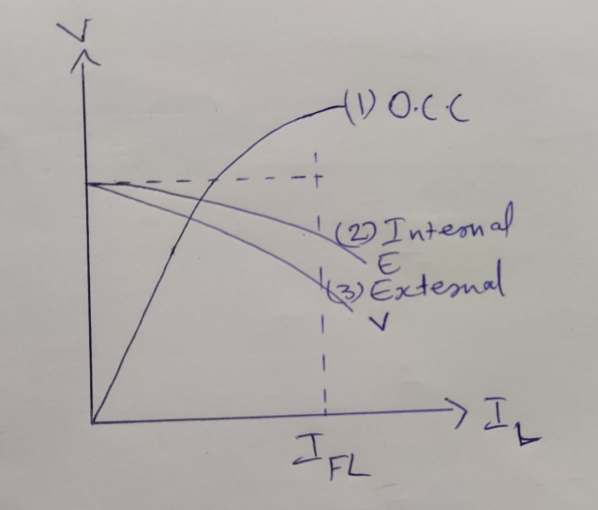

DC Shunt Generator

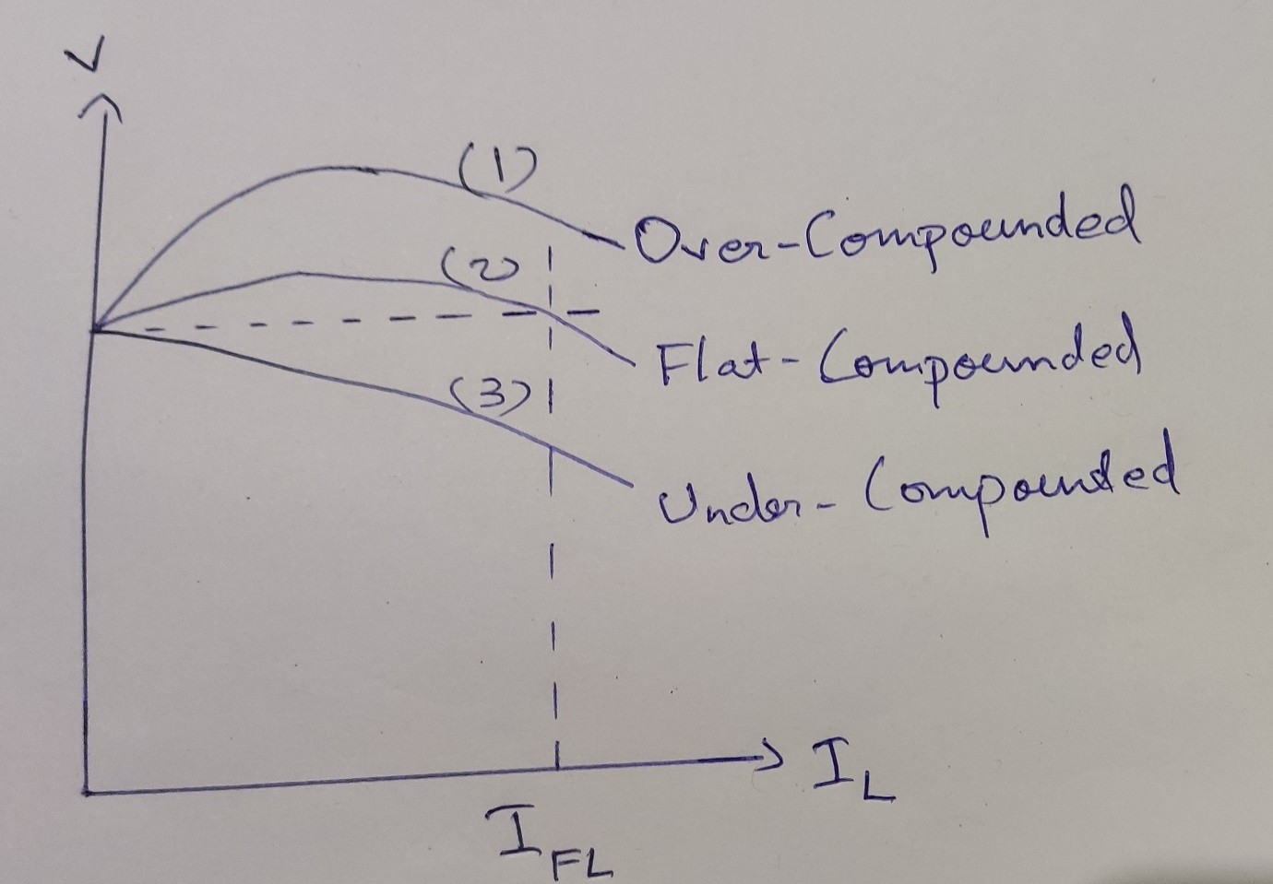

DC Compound Generator

1. What are the different types of DC generators?

#### Separately Excited DC Generators

External DC source (e.g., battery) is used in this system for energizing field magnets. As the rotation speed increases, it can provide a higher EMF and voltage in the output.

#### Self-Excited DC Generators

Self-excited DC generators have field magnets that are energized by their own supplied current, and the field coils are connected to the armature internally.

* + Shunt Wound Generators
  + Compound Wound Generators
  + Series Wound Generators

1. How the generators are classified based on method of excitation?

#### Separately Excited DC Generators

External DC source (e.g., battery) is used in this system for energizing field magnets. As the rotation speed increases, it can provide a higher EMF and voltage in the output.

#### Self-Excited DC Generators

Self-excited DC generators have field magnets that are energized by their own supplied current, and the field coils are connected to the armature internally.

1. State the application of various types of generators.

#### AC Generators

* + Marine alternators
  + Brushless alternators
  + Diesel-electric locomotive alternators
  + Automotive alternators
  + Radio alternators **DC Generators**

Applications of Separately Excited DC Generators

* + These are able to produce a wide range of voltage output, they are primarily used in laboratory and commercial testing.
  + These are used in speed regulation tests.

Applications of Series DC Generators

* + The rising characteristics of a series DC generator makes it suitable for voltage boosting applications in the feeders in the various types of distribution systems.
  + A series DC generator has the tendency to supply constant load current.

Hence, several series generators can be connected in series to provide high voltage DC power transmission at constant load current.

Applications of Shunt DC Generators

* + They are used for battery charging applications.
  + Use for giving excitation to the alternators.

Application of DC Compound Generators

* + Cumulative compound generators are used for supplying power to DC motors.
  + Cumulative compound generators are used for lighting, power supply purposes

1. Define back pitch and front pitch.

The number of armature conductors or elements spanned by a coil on the front is called **front pitch.**

A coil advances on the back of the armature. This advancement is measured in terms of armature conductors and is called **back pitch**. It is equal to the number difference of the conductor connected to a given segment of the commutator.

#### PART 4A

1. Derive an expression for the emf of DC generator.

An emf is induced in a DC generator, when a conductor is rotated in a magnetic field. The emf induced in a conductor depends on the speed of rotation of the conductor and the flux produced from a field winding.

Let us drive the equation of an emf induced in a DC generator. Before deriving the equation, learn about the construction and working principle of DC generator.

Let P = number of poles.

Z = total number of conductor in the armature.

A = number of parallel paths, into which the conductors are grouped. So each parallel path will have Z/A conductor in series.

N = speed of the rotor in revolution per minute(rpm) N/60 = Speed of the rotor in revolutions per second.

Time taken by the rotor to complete one revolution, dt = 1/(N/60)= 60/N second

In one revolution of the rotor, the total flux Φ cut the by each conductor in the stator poles, dΦ = ΦP weber

By faraday’s law of electromagnetic induction, the emf induced is proportional to rate of change of flux.

Average EMF induced per conductor = (dΦ)/dt = (ΦNP)/60

Since there are Z/Aconductor in series in each parallel path, the emf induced is given by

E = (ΦNPZ)/60A

The above equation represents the general equation for emf induced in a DC generator. The armature conductors in a DC generator can be connected in two ways. They are lap winding and wave winding.

For lap wound machines, the number of parallel paths is equal to the number of poles (A = P).

For such machine, the emf equation is given by,

E = (ΦNZ)/60

In wave wound machine, the number of parallel paths is equal to 2(A = 2). The emf equation of a wave wound machine is given by,

E = (ΦNPZ)/120

1. Write notes on the following:

#### Self and separately excited DC generators.

A **separatelyexcited**DCgeneratoris the one whose field winding is supplied by an independent external DC source (like a battery). The magnitude of generated voltage depends upon the speed of rotation of armature and the field current, i.e., greater the speed and the field current, higher is the generated voltage. In practice, the separately excited DC generators are rarely used.

A **self-excited** DC generator is the one whose field winding is excited by the current from the output of the generator itself. Depending upon the connection of field winding with the armature, the self-excited DC generators are of three types –

* + Series Generator
  + Shunt Generator
  + Compound Generator

#### Commutation

The currents induced in the armature conductors of a DC generator are alternating in nature. The change from a generated alternating current to the direct current applied involves the process of **Commutation**. When the conductors of the armature are under the north pole, the current which is induced flows in one direction. While the current flows in the opposite direction when they are under the south pole.

As the conductor passes through the influence of the north pole and enters the south pole, the current in them is reversed. The reversal of current takes place along the MNA or brush axis. When the brush span has two commutator segments, the winding element connected to those segments is short-circuited.

The term Commutation means the change that takes place in a winding element during the period of a short circuit by a brush.

1. Obtain the condition for maximum efficiency of the DC generator.

#### Electrical Efficiency

It is defined as the ratio of the output power in mechanical to the armature power.

*ηe = [ Output power in mechanical ] × 100% / [ Armature power ]* ***Condition For Maximum Efficiency***

Generator output power = VIL

Generator input power = Output power + Total losses

= VIL + Constant losses + Copper losses

= VIL + WC + Ia2Ra

= VIL + WC + ( IL + Ish )2 Ra

The value of shunt field current is very small as compared to load current therefore the shunt field current is neglected.

Generator input power = VIL + WC + ( IL )2 Ra Generator efficiency = Output power / Input power

= VIL / VIL + WC + ( IL )2 Ra

= 1 / [ 1 + ( WC / VI 2 + IL Ra / V ) ]

*L*

The load current is variable parameter therefore the generator efficiency becomes maximum when

dη / dIL = 0

d / dIL [( WC / VIL2 + IL Ra / V ) ] = 0

( WC / V ) ( 1 / – I 2 ) + ( Ra / V ) ( 1 ) = 0 IL2 Ra = WC

*L*

Therefore the variable losses is equal to constant losses is condition for maximum efficiency in the DC Generator.

1. Explain the different methods of excitation and characteristics of DC generators with suitable diagrams.

Thus supplying current to the field winding is called excitation and the way of supplying the exciting current is called **method of excitation**.

There are two methods of excitation used for d.c. generators.

* + Separate excitation
  + Self excitation

In **separately excited generator**, a separate external d.c. supply is used to provide exciting current through the field winding.

The d.c. generator produces d.c. voltage. If this generated voltage itself is used to excite the field winding of the same d.c. generator, it is called **self excited generator**.

#### Characteristics

**Open Circuit Characteristic (O.C.C.) (E0/If)**

Open circuit characteristic is also known as magnetic characteristic or no-load saturation characteristic. This characteristic shows the relation between generated emf at no load (E0) and the field current (If) at a given fixed speed.

#### Internal Or Total Characteristic (E/Ia)

An internal characteristic curve shows the relation between the on-load generated emf (Eg) and the armature current (Ia). The on-load generated emf Eg is always less than E0 due to the armature reaction. Eg can be determined by subtracting the drop due to demagnetizing effect of armature reaction from no-load voltage E0. Therefore, internal characteristic curve lies below the O.C.C. curve.

#### External Characteristic (V/IL)

An external characteristic curve shows the relation between terminal voltage (V) and the load current (IL). Terminal voltage V is less than the generated emf Eg due to voltage drop in the armature circuit. Therefore, external characteristic curve lies below the internal characteristic curve. External characteristics are very important to determine the suitability of a generator for a given purpose. Therefore, this type of characteristic is sometimes also called as performance characteristic or load characteristic**.**

#### Characteristics curve

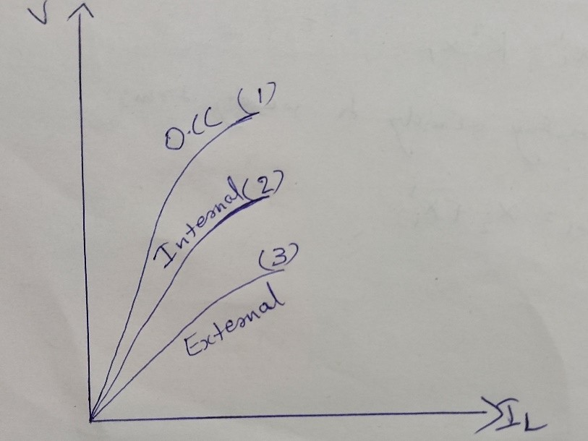

1. I) Explain armature reaction and commutation in detail.

* In armature winding armature current passes that have its own flux in armature winding that interacts with the stator flux and decreases its effect that creates serious problems for the operation of a machine. This distortion in field winding due to the armature flux is known as **armature reaction.**
* The currents induced in the armature conductors of a DC generator are alternating in nature. The change from a generated alternating current to the direct current applied involves the process of **Commutation**. When the conductors of the armature are under the north pole, the current which is induced flows in one direction. While the current flows in the opposite direction when they are under the south pole.

As the conductor passes through the influence of the north pole and enters the south pole, the current in them is reversed. The reversal of current takes place along the MNA or brush axis. When the brush span has two commutator segments, the winding element connected to those segments is short-circuited.

ii) Draw the OCC Characteristics and External Characteristics of DC generator.

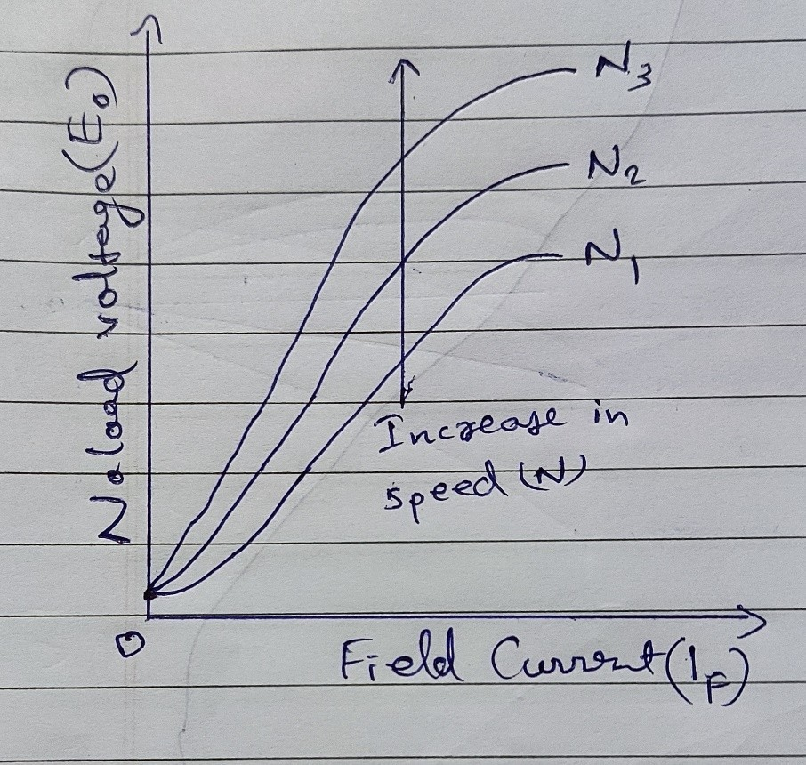

O.C.C of DC Generator

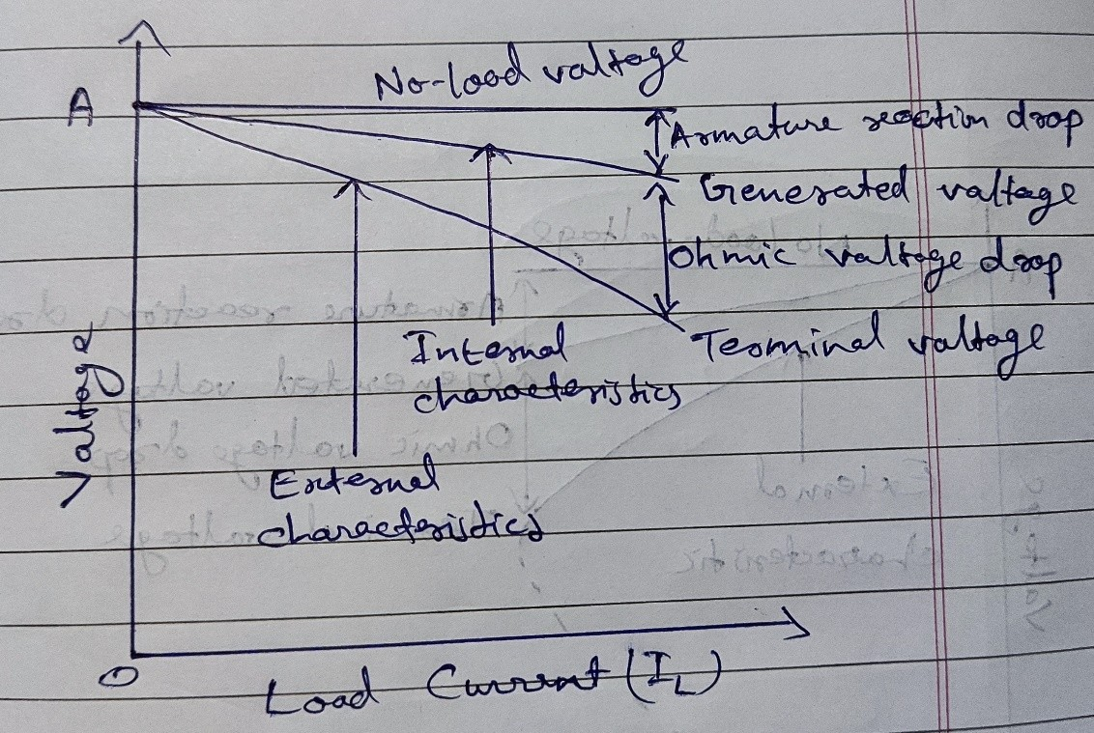

External characteristics of Separately Excited DC Generator

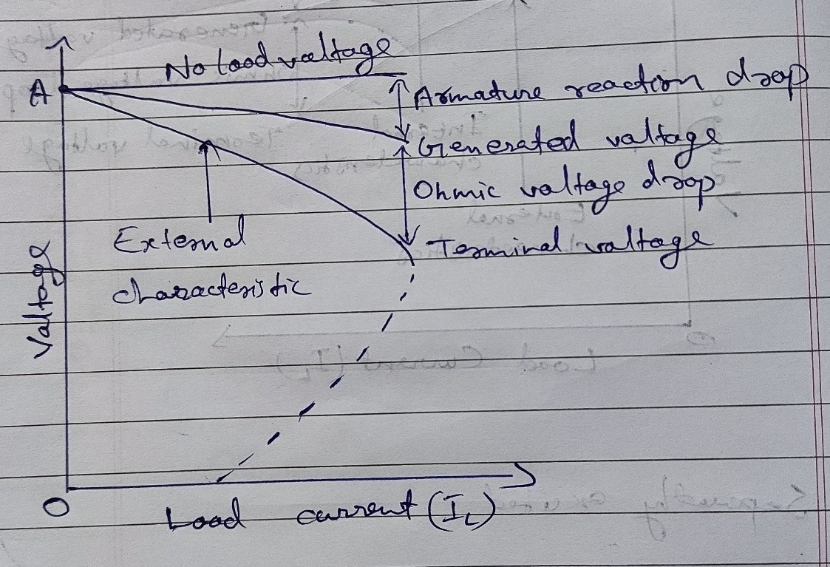

External characteristics of DC Shunt Generator

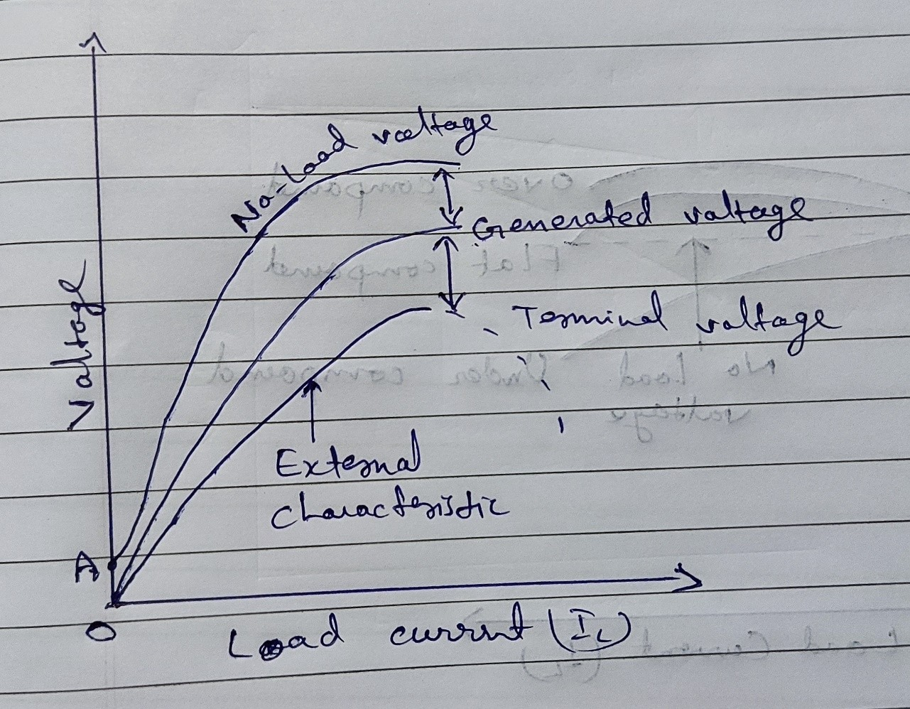

External characteristics of DC Series Generator

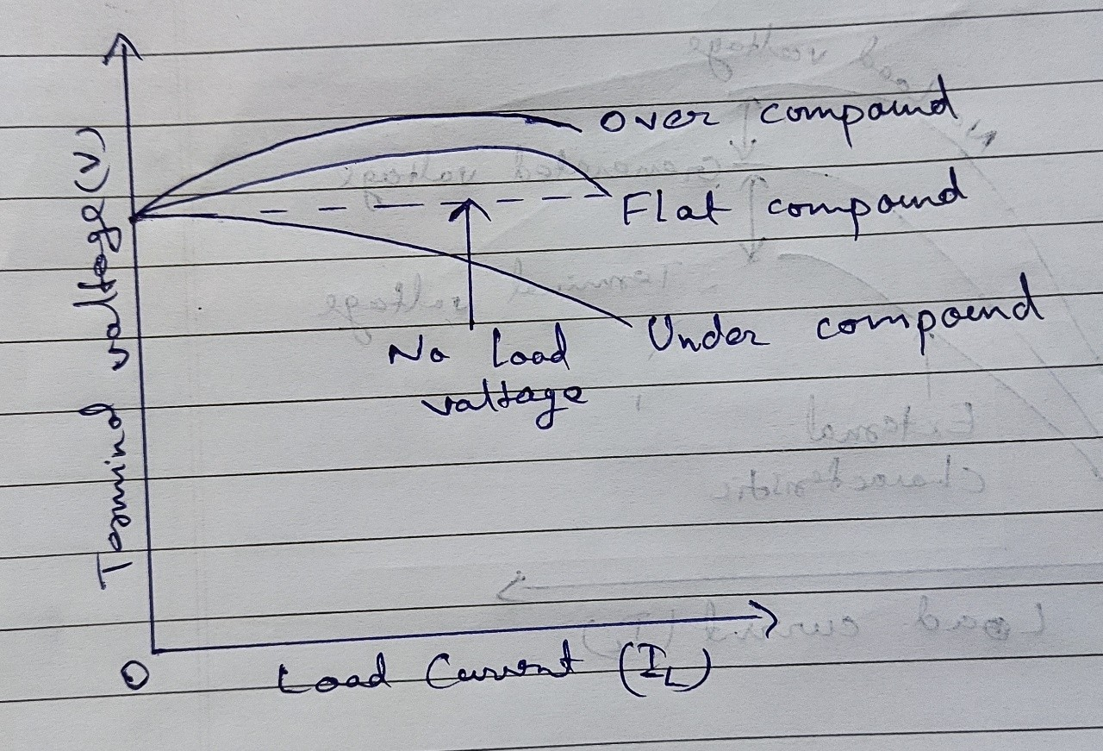

External characteristics of DC compound generator

#### PART 5

1. Why the Starters necessary for starting DC motors?

A starter is a device to start and accelerate a motor. While starting the DC motor, it draws the heavy current which damages the motor. The starter reduces the heavy current and protects the system from damage.

1. Why is belt drive not suitable for DC series motor?

A DC series motor can drive to dangerously high speed at no load, so a belt drive may snap while operating the motor.

1. What is the significance of back EMF in a DC motor?

The armature current drawn by the DC motor is given by,

Ia = (V-Eb)/Ra

Hence, the back EMF makes the DC motor a self-regulating machine, it automatically changes armature current to meet load requirement as follows:

* + When the motor is running at no-load, a small torque is required to overcome the mechanical losses. Hence, the Ia is small and back emf is nearly equal to the applied voltage.
  + Now, if the load is connected to the motor, it causes the armature to slow down and hence, the back emf decreases. The decreased back emf causes the larger current to flow through the armature and the large armature current means increased developed torque by the motor. Hence, the torque is increased when the motor slows down. The motor will stop slowing down when the armature current is sufficient to produce the increased torque required by the load
  + When the load on the motor is decreased, then the torque is momentarily more than the requirement so that the armature is accelerated. As the speed of the armature increases, the back emf also increases and causes the armature current is decrease. The motor will stop accelerating when the armature current is sufficient to develop the torque required by the load.

1. Why DC series motor called variable speed motor?

DC series motor have series armature and field winding, so when load increases the armature draws more current and the same will flow through field to produce flux. Motor speed is inversely proportional to field flux so, as current increases speed decreases.

1. List the merits and demerits of Swinburne’s test.

Merits of Swinburne’s test:

* + The power required for the testing of large machines is very small, therefore it is an economical and convenient method of testing DC machines.
  + As the constant losses are known, thus the efficiency can be pre-determined at any load.

Demerits of Swinburne’s test:

* + The change in iron losses is not considered from no-load to full load. At full load, due to the armature reaction, the flux is distorted which increases the iron losses.
  + Since the Swinburne’s test is performed on no-load, thus it does not indicate whether the commutation on full load is satisfactory and whether the temperature rise would be within specified limits.

1. What are the methods of speed control in DC motor?

The speed can be varied by changing:

* + The terminal voltage of the armature, V.
  + The external resistance in armature circuit, Ra.
  + The flux per pole, φ.

1. Mention the application of various DC motor.

Application of DC series motor

* + DC series motors are used where high starting torque required. These motors are only used where the variation of speed is possible. series motors are not suitable for constant speed applications.
  + DC series motor is used in a vacuum cleaner, traction systems, sewing machines, cranes, air compressors etc.

Application of DC shunt motor

* + DC shunt motors are used where constant speed is needed. So these motors are commonly used in fixed speed applications.
  + This type of motor is used in Lathe Machines, Centrifugal Pumps, Fans, Blowers, Conveyors, Lifts, Weaving Machine, Spinning machines, etc.

Application of DC Compound motor

* + By compound motor, we get high starting torque and nearly constant speed. Because of that Compound motors are used where we require high starting torque and constant speed.
  + A compound motor is used in Presses, Shears, Conveyors, Elevators, Rolling Mills, Heavy Planners, etc.

1. Give few applications of Ward-Leonard systems.

Applications of Ward-Leonard system:

* + Mine hoists
  + Elevators
  + Steel rolling mills
  + Paper machines
  + Diesel locomotives
  + Cranes

1. Draw the characteristics of DC compound motor.

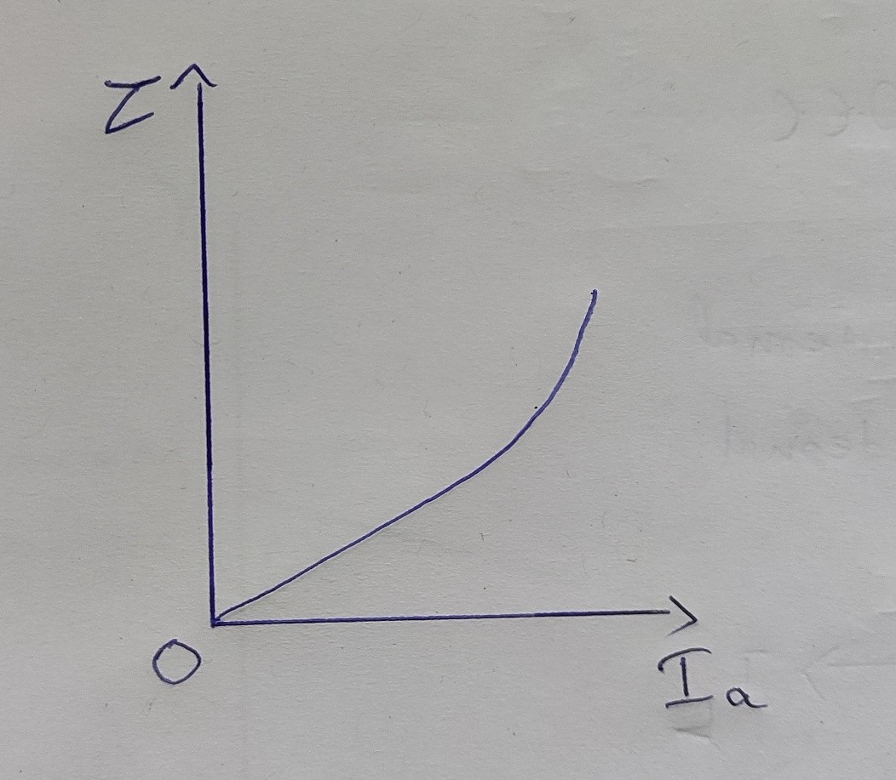

Torque and Armature current characteristic

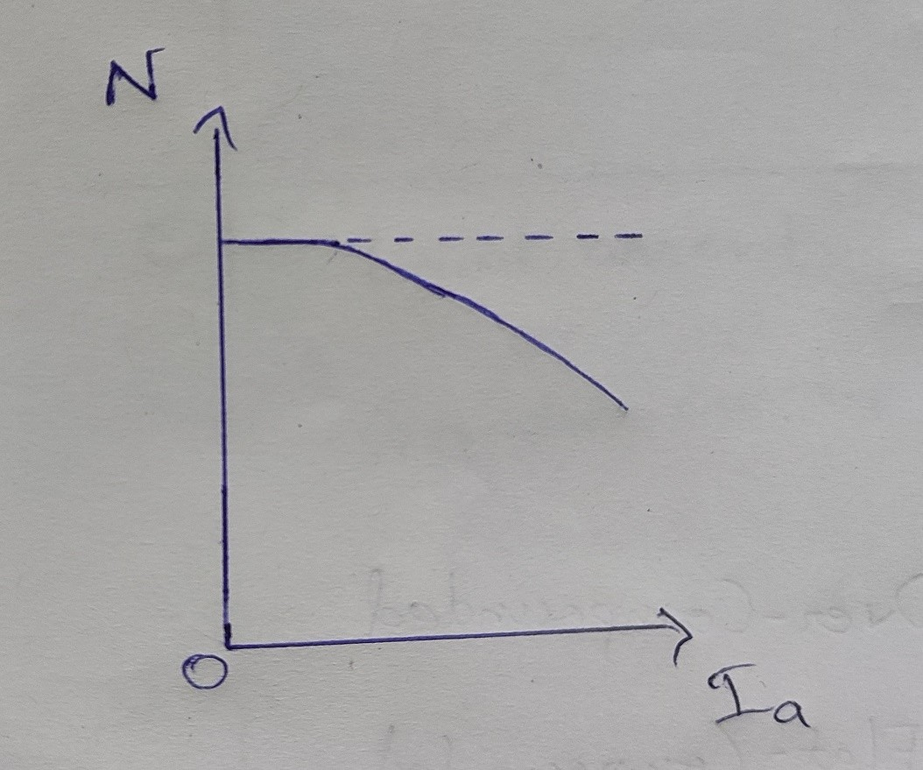

Speed and Armature current characteristic

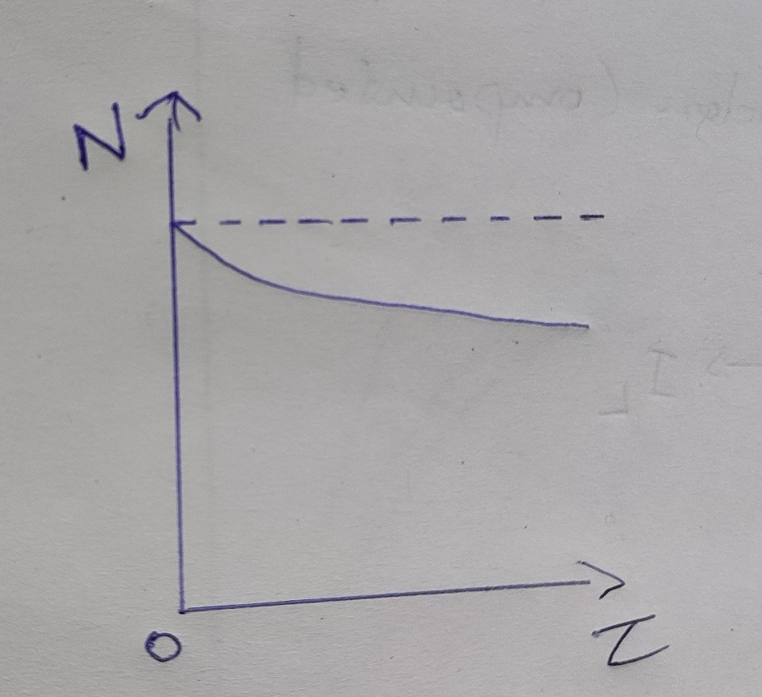

Speed and Torque characteristic

1. State the voltage equation of DC motor.

Consider the following circuit, where V is the supply voltage, Eb is the back EMF, Ia is the armature current and Ra is the armature resistance.

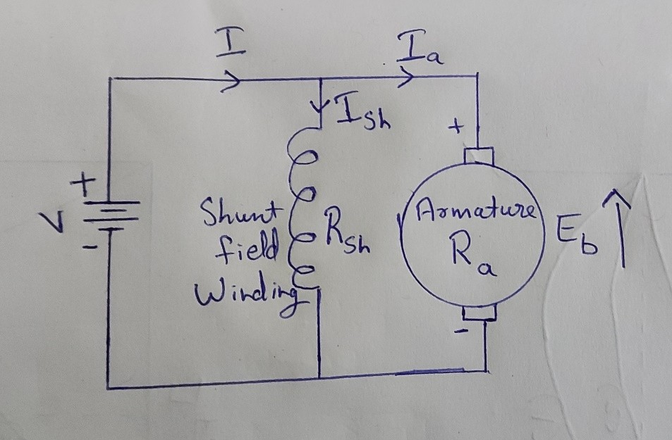

By applying KVL to the loop shown in the circuit, the voltage equation can be written as,

V = Eb + IaRa

1. State Fleming’s left hand rule.

If we arrange the thump, the centre finger and forefinger of the left hand at right angle to each other, then the thump points towards the direction of magnetic force, the centre finger points towards the direction of current and the forefinger shows the direction of magnetic field.

1. How to reverse the direction of rotation of dc motor?

The direction of rotation may be reversed by changing the direction of the current either in the series field or the armature.

1. What is Back EMF?

When the armature of DC motor rotates under driving torque, the armature conductor moves through the magnetic field and hence an EMF is induced in it. The induced EMF acts opposite to the direction of applied voltage and is called Back EMF (Eb).

1. Write the torque equation of a DC motor.

Torque,

Τav = (PZφIa)/2**π**A

P = Number of poles of the machine Z = Number of armature conductors Φ = flux

A = Number of parallel paths

1. Draw the Speed-Current and torque-current Characteristics of a DC series motor.

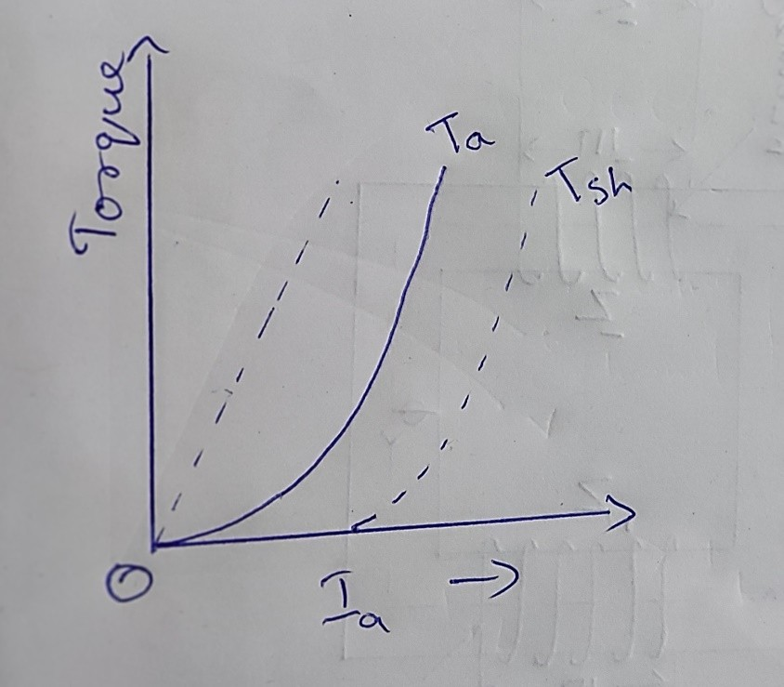

Torque – current characteristic

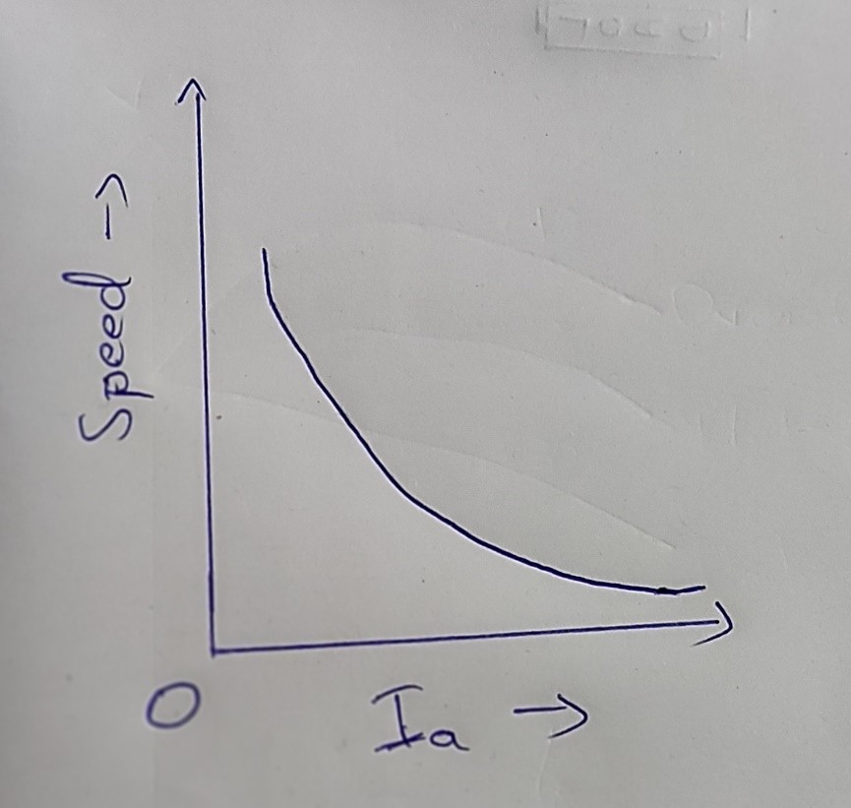

Speed – current characteristic **PART 5A**

1. Explain the different methods of excitation and characteristics of a DC motors with suitable diagrams.

Methods of excitation:

**Separately Excited** motors produce their field flux by an externally connected source.

**Self-excited** motors produces field flux by connecting the field winding with the armature.

* + Shunt Motor

A field winding consist of a large number of turns of thin wire excited in parallel to the armature and hence is called shunt motor.

* + Series Motor

The field winding has few turns of thick wire connected in series with armature.

* + Compound Motor

The field winding comprises of both shunt and series windings and can either be short shunt or long shunt.

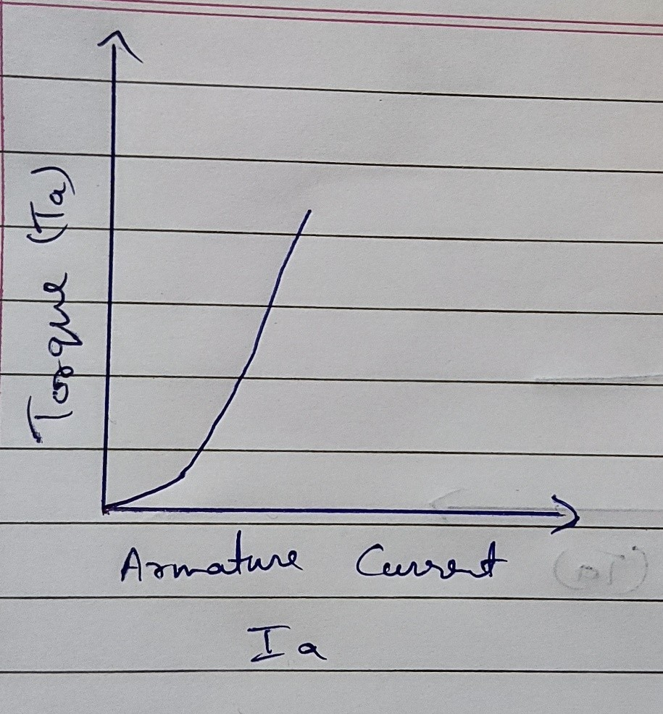

Tourque vs Armature current

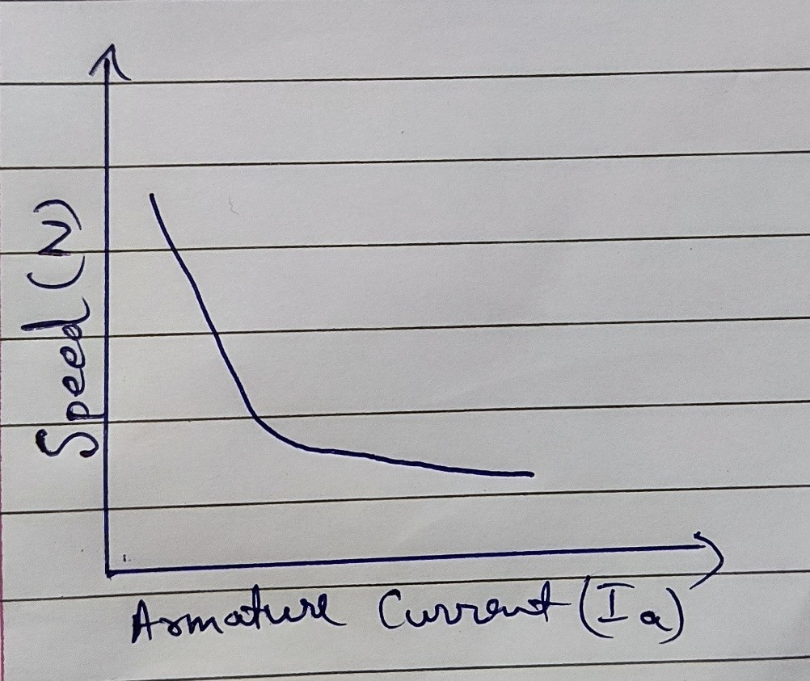

Speed vs Armature current

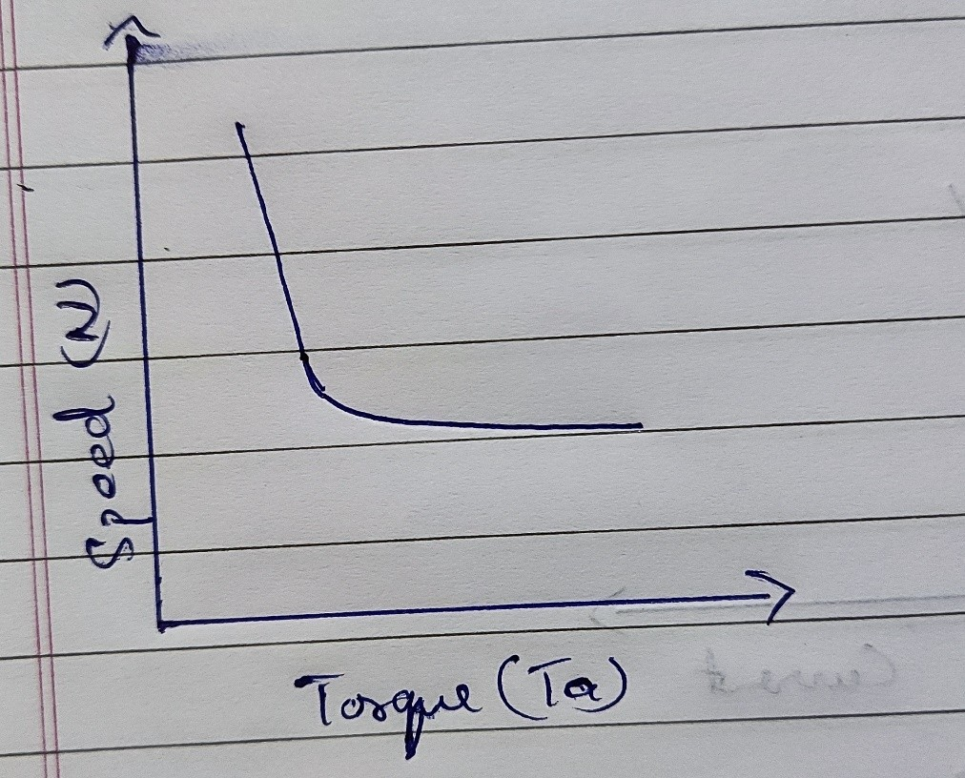

Speed vs Torque

1. Explain the various methods of controlling the speed of a DC shunt motor and bring out their merits and demerits. Also, state the situations where each method is suitable.

### Speed Control of DC Shunt Motor

The classification of **speed control methods for a DC shunt motor** are similar to those of a DC series motor. These two methods are:

* + Armature Control Methods
  + Field Control Methods **Armature Controlled DC Shunt Motor**

Armature controlled DC shunt motor can be performed in two ways:

* + Armature resistance control
  + Armature voltage control

**Armature resistance control**: In armature resistance control a variable resistance is added to the armature circuit. Field is directly connected across the supply so flux is not changed due to variation of series resistance. This is applied for DC shunt motor. This method is used in printing press, cranes, hoists where speeds lower than rated is used for a short period only.

**Armature voltage control:** This method of speed control needs a variable source of voltage separated from the source supplying the field current. This method avoids disadvantages of poor speed regulation and low efficiency of armature-resistance control methods.

The basic adjustable armature voltage control method of speed d control is accomplished by means of an adjustable voltage generator is called **Ward Leonard System**. This method involves using a motor-generator (M-G) set. This method is best suited for steel rolling mills, paper machines, elevators, mine hoists, etc. This method is known as Ward Leonard System.

Advantages of Armature Controlled DC Shunt Motor

* + Very fine speed control over whole range in both directions
  + Uniform acceleration is obtained
  + Good speed regulation
  + It has regenerative braking capacity Disadvantages of Armature controlled DC Shunt Motor
  + Costly arrangement is needed, floor space required is more
  + Low efficiency at light loads
  + Drive produced more noise.

Applications

* + Printing machines
  + Cranes
  + Hoists
  + Fans
  + Blower

#### Field Controlled DC Shunt Motor

By this method a DC Shunt motor’s speed is controlled through a field rheostat. **Field Rheostat Controlled DC Shunt Motor:** In this method, speed variation is accomplished by means of a variable resistance inserted in series with the shunt field. An increase in controlling resistances reduces the field current with a reduction

in flux and an increase in speed. This method of speed control is independent of load on the motor. Power wasted in controlling resistance is very less as field current is a small value. This method of speed control is also used in DC compound motor.

Disadvantages of Field Rheostat Controlled DC Shunt Motor

* + Creeping speeds cannot be obtained.
  + Top speeds only obtained at reduced torque.
  + The speed is maximum at minimum value of flux, which is governed by the demagnetizing effect of armature reaction on the field.

Applications

* + Where high speed above no-load speed is required.

1. i) Draw and explain the characteristics of compound motor.

#### Characteristics of DC Compound motor

Compound motors have both series field winding and shunt field winding. Based on the excitation, they are of two types, namely cumulatively compound and differentially compound motors.

**Cumulative compound motor:** If the series field flux assists the shunt field flux, then it is a cumulatively compound motor. Such machines have the characteristics of both series motor and shunt motor.

They are used in applications where the load is likely to be removed totally. Due to the shunt field windings, the speed will not become excessively high. At the same time, the series field windings will be able to take up heavy loads. Cumulative compound motors are used for high starting torque applications as in

cranes, elevators, etc. Also used for applications where sudden apply and removal of loads are essential.

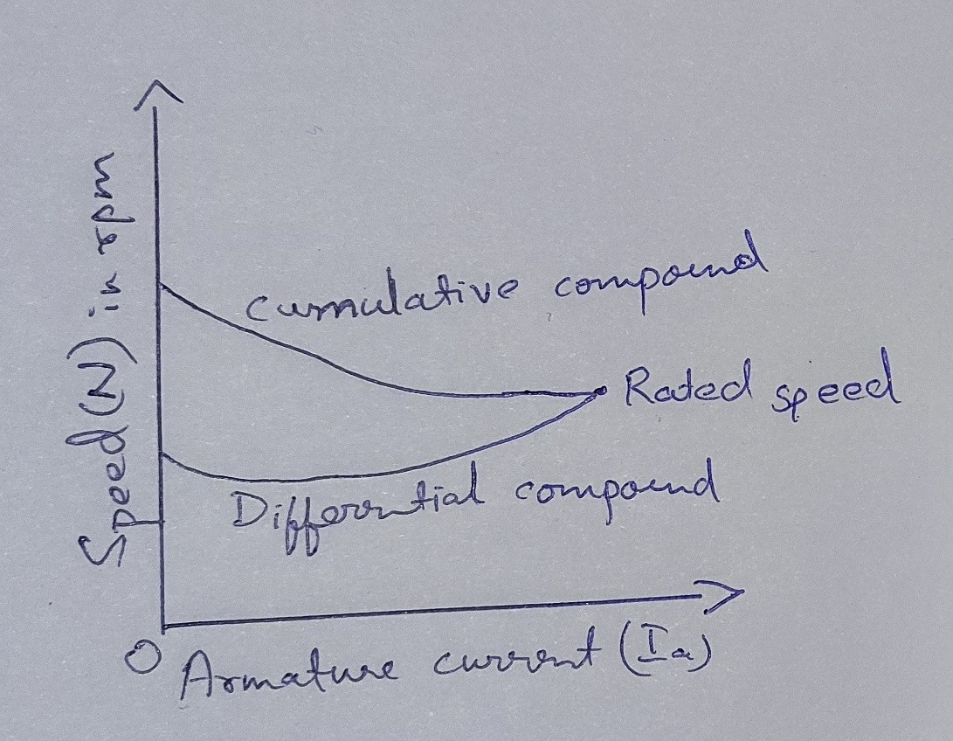

Speed vs armature current characteristics

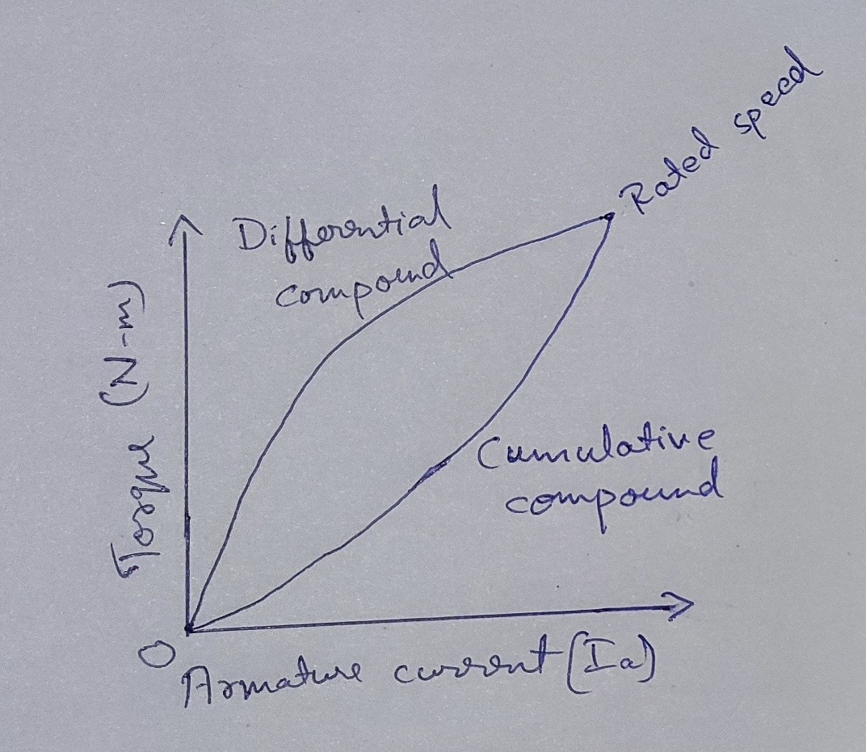

Torque vs Armature current characteristics

**Differential Compound motor:** In this machine, the flux produced by the series field

winding opposes and reduces the flux produced by the shunt field winding. Hence the net flux decreases with an increase in load.

As a result, the motor speed increases (NαEb/φ). This causes the motor torque to reduce which makes the differential compound motor not suitable to operate for overload conditions. Such motors are rarely employed in practice.

1. Explain the factor affecting the speed of a DC motor.

According to the speed equation,

N ∝ Eb/ Φ ∝ (V-IaRa)/ Φ The factors Z, P, A are constants for a d.c. motor.

But as the value of armature resistance Ra and series field resistance Rse is very small, the drop IaRa and (Ra + Rse) is very small compared to applied voltage V. Hence neglecting these voltage drops the speed equation can be modified as,

N ∝ V/ Φ and Eb ∝ V Thus the factors affecting the speed of a d.c. motor are,

* + The flux Φ
  + The voltage across the armature
  + The applied voltage V

1. i) What are the various starting methods of DC motor? Explain any one method.

#### DC Motor Starters

To avoid the above dangers while starting a DC motor, it is necessary to limit the starting current. So, a DC motor is started by using a starter. There are various **types of dc motor starters**:

* + 3 point starter
  + 4 point starter
  + no-load release coil starter
  + thyristor controller starter etc.

The basic concept behind every DC motor starter is adding external resistance to the armature winding during starting.

### 3 Point Starter

The internal wiring of a **3 point starter** is as shown in the figure.

When the connected dc motor is to be started, the lever is turned gradually to the right. When the lever touches point 1, the field winding gets directly connected across the supply, and the armature winding gets connected with resistances R1 to R5 in series. During starting, full resistance is added in series with the armature winding. Then, as the lever is moved further, the resistance is gradually is cut out from the armature circuit. Now, as the lever reaches to position 6, all the resistance is cut out from the armature circuit and armature gets directly connected across the supply. The electromagnet 'E' (no voltage coil) holds the lever at this position. This electromagnet releases the lever when there is no (or low) supply voltage.

It can be seen that, when the arm is moved from the position 1 to the last position, the starter resistance gets added in series with the field winding. But, as the value of starter resistance is very small as compared to the shunt resistance, the decrease in shunt field current may be negligible. However, to overcome this drawback a brass or copper arc may be employed within a 3 point starter which makes a connection between the moving arm and the field winding, as shown in the figure of 4 point starter below.

When the motor is overloaded beyond a predefined value, 'overcurrent release electromagnet' D gets activated, which short-circuits electromagnet E and, hence,

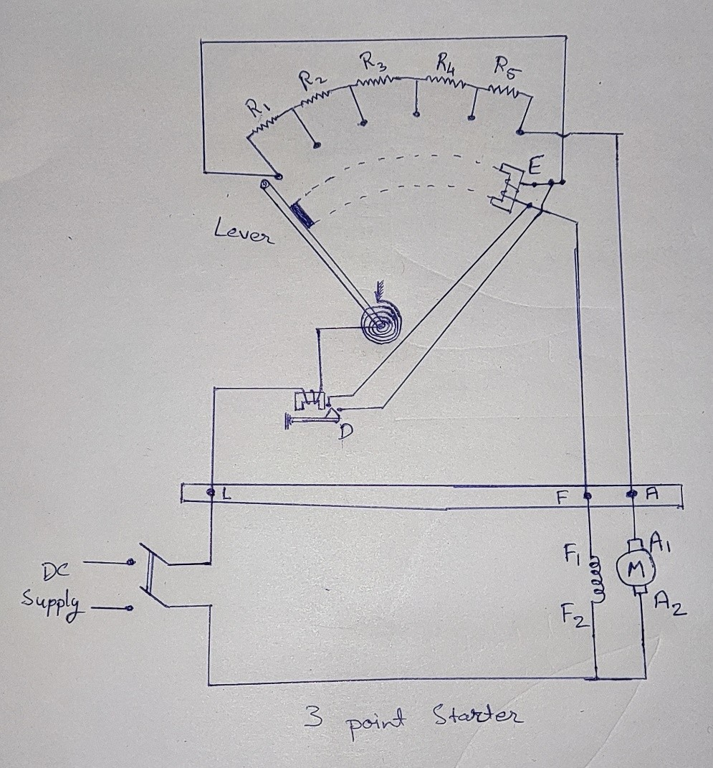releases the lever and the motor is turned off.

1. Explain in detail the various method of speed control in DC motor.

#### Speed Control of DC Motor

The relationship given below gives the speed of a D.C. motor

N = (V-IaRa)/k Ф

The above equation shows that the speed depends upon the supply voltage V, the armature circuit resistance Ra, and the field flux Ф, which is produced by the field current. In practice, the variation of these three factors is used for speed control. Thus, there are three general methods of speed control of D.C. Motors.

* + Resistance variation in the armature circuit: This method is called armature resistance control or Rheostat control.
  + Variation of field flux Ф. This method is called field flux control.
  + Variation of the applied voltage. This method is also called armature voltage control.

#### Armature Resistance Control (Rheostat control)

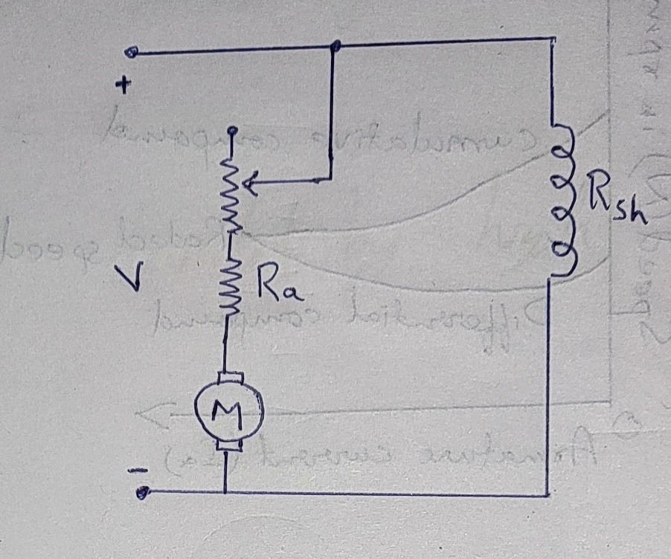

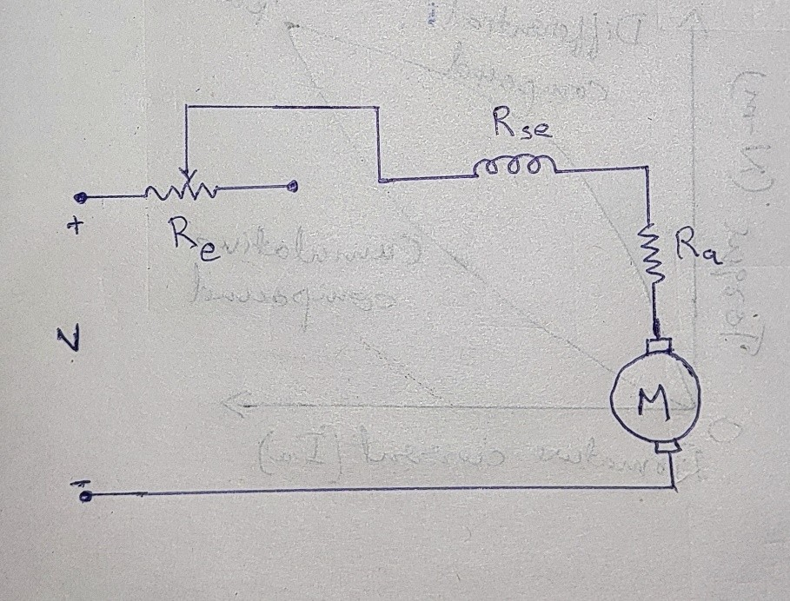Speed control of DC Shunt motor

Speed control of DC Series motor

In this method, a variable series resistor Re is put in the armature circuit. The figure (a) above shows the process of connection for a shunt motor. In this case, the field is directly connected across the supply and therefore the flux Ф is not affected by variation of Re.

Figure (b) shows the method of connection of external resistance Re in the armature circuit of a D.C. series motor. In this case, the current and hence the flux is affected by the variation of the armature circuit resistance.

The voltage drop in Re reduces the voltage applied to the armature, and therefore the speed is reduced. This method is only used for small motors.

### Variation of field flux Ф (Field flux control)

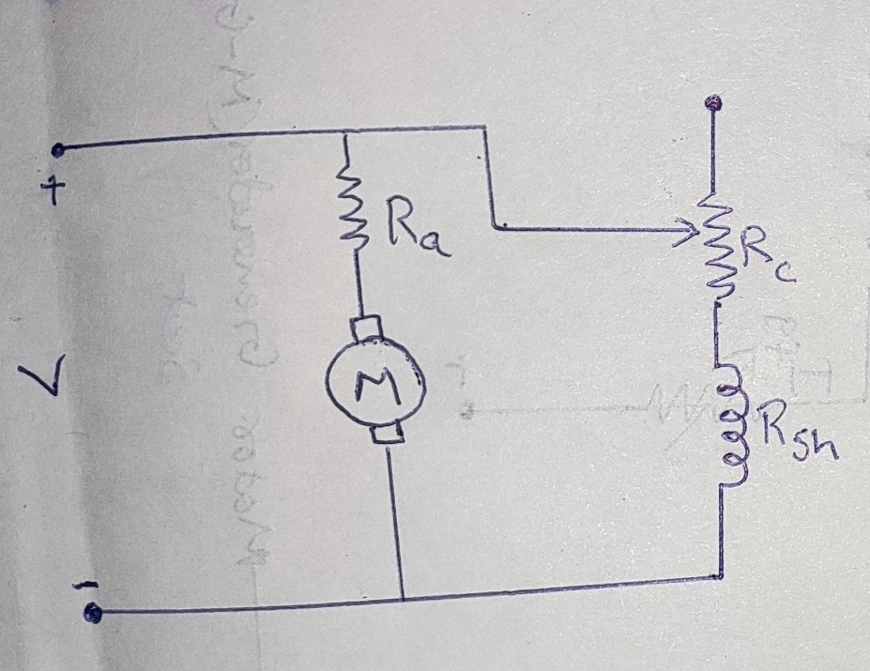

Speed control of DC Shunt motor

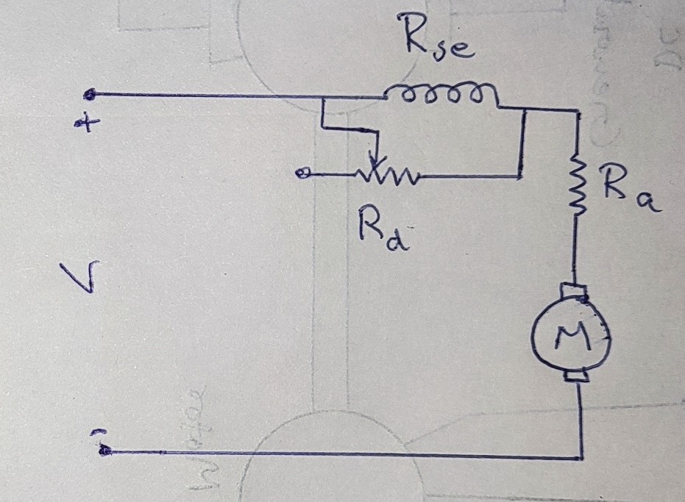

The diverter in parallel with the series of D.C. Motor.

Ish = V/(Rsh+Rc), gives the shunt field current

Any of the one methods can vary the field current of the series motor:

* + A variable resistance Rd is connected in parallel with the series field winding. The resistor connected in parallel is called the **diverter**. A portion of the main current is diverted through Rd.
  + The second method uses a tapped field control.

Here the ampere-turns are varied by varying the number of field turns. This arrangement is used in electric traction.

### Armature Voltage control

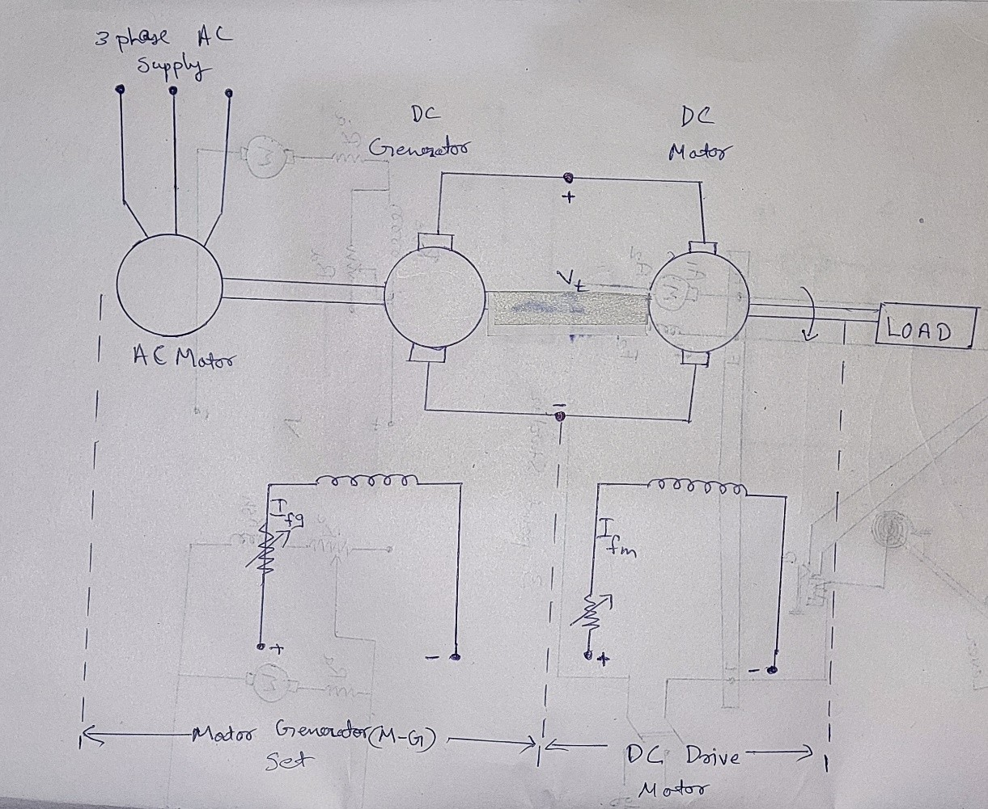

Ward-Leonard drive

We can control the speed of the D.C. motors by varying the applied voltage to the armature. Ward-Leonard system of speed control works on this principle of armature voltage control. In this system, M is the main dc motor whose speed is to be controlled, and G is a separately excited dc generator. The generator G is driven by a 3- phase driving motor which may be an induction motor or asynchronous motor. The combination of ac driving motor and the dc generator is called the motor-generator (M-G) set.

1. With neat circuit diagram explain the conduction of Swinburne’s test.

### Swinburne’s Test

Swinburne’s test is an indirect method of testing DC machines, named after Sir James Swinburne. In this method, the losses are determined separately and the efficiency at desired load is predetermined. The Swinburne’s test is the simplest method of testing of shunt and compound DC machines which have constant field flux.

The connection diagram is shown in the figure and the machine is run as a motor at rated voltage and speed.

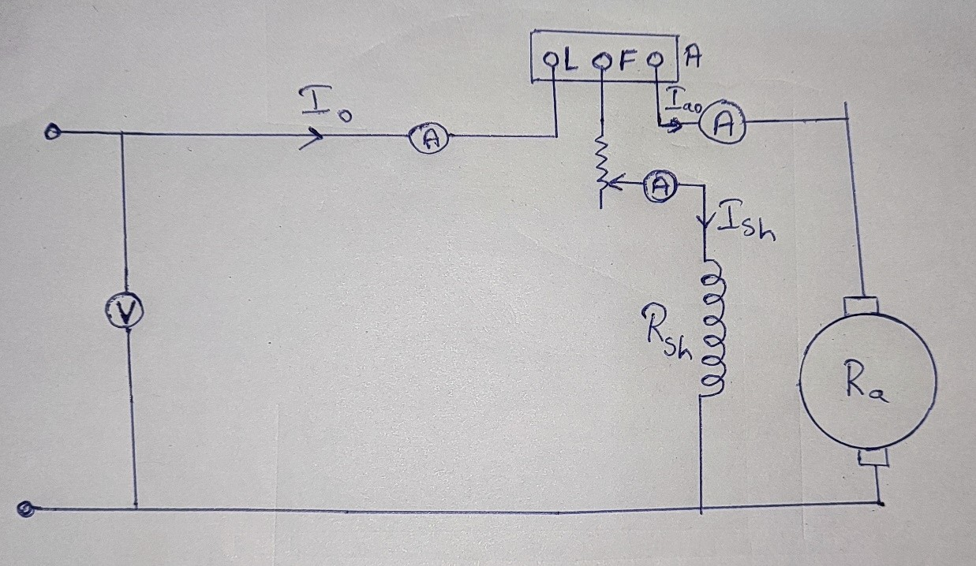

Let,

And

V=Supply voltage

I0 = No-load line current Ish = Shunt field current

∴No-load armature current, Ia0 = I0−Ish

No-load input power = VI0

This no-load input power of the machine supplies the following –

* Core loss
* No-load armature cu loss
* Friction and windage loss

At no-load the useful mechanical output of the machine is zero, thus the no-load input power is only used to supply the losses in the machine. Hence,

Armaturecu−lossatno−load=(Ia0)2Ra Where, Ra is the resistance of armature winding.

Therefore, the constant power losses in the machine will be,

Pc = No-load input power − No-load armature cu loss

⇒Pc = VI0 − (Ia0)2Ra

Now, after knowing the constant losses of the machine, its efficiency at any other load can be determined as follows –

Consider "I" is the load current at which the efficiency of the machine is to be calculated.

#### Efficiency when running as Motor Here,

Armature current, Ia = I − Ish

Motor input power = VI Armature Cu loss = (Ia)2 * Ra = (I − Ish)2 * Ra

∴Total losses in the machine= (I − Ish)2 Ra + Pc Where, PC is the constant losses which is determined above. Therefore,

Efficiency of Motor, ηm = Output/Input = (Input−Losses)/Input

ηm=[VI − (I − Ish)2 * Ra− Pc ]/VI

#### Efficiency when running as Generator Here,

Armature current, Ia= I + Ish Generator output power = VI

Armature Cu loss = (Ia)2 * Ra = (I + Ish)2 Ra

∴Total losses in the machine = (I + Ish)2 * Ra + Pc Efficiency of Generator, ηg = Output/(Output + Losses)

=VI/[VI + (I + Ish)2 * Ra + Pc]

#### Advantages of Swinburne’s Test

Following are the advantages of Swinburne’s test –

* The power required for the testing of large machines is very small, therefore it is an economical and convenient method of testing DC machines.
* As the constant losses are known, thus the efficiency can be pre-determined at any load.

#### Disadvantages of Swinburne’s Test

The main disadvantages of the Swinburne’s test are –

* The change in iron losses is not considered from no-load to full load. At full load, due to the armature reaction, the flux is distorted which increases the iron losses.
* Since the Swinburne’s test is performed on no-load, thus it does not indicate whether the commutation on full load is satisfactory and whether the temperature rise would be within specified limits.

#### Limitations of the Swinburne’s Test

The Swinburne’s test has the following limitation –

* The Swinburne’s test is only applicable only to those DC machines in which the flux is practically constant, which are shunt machines and level compound generators.
* The series DC machines cannot be test by Swinburne’s test since they cannot be run on no-load and their flux and speed very greatly.